Short term plan: term 3

Unit: 5 Creativity |  | Lesson 49
Teacher name:

Date:
Grade: 5 |  | Number present: | absent:
Lesson title | Vocabulary: Art
Learning objectives | 5. 2. 8. 1 understand with support a range of longer conversations on general and academic topics, including stories  5. 3. 1. 1 provide basic information abou  t oneself and others at the sentence level within a number of general topics;  5. 6. 3. 1 in general and educational topics, the use of descriptive nouns, including dependent adjectives, the
Lesson objectives | Learners will be able to:  - learn vocabulary for different Arts activities.  - talk about what Arts activities you do.
Value links | "Law and Order"  Know the basics of the legal system and human rights
Plan

Stages / Time | Teachers actions | Students actions | Assessment criteria | Resources
Beginning of the lesson  5 min.  Middle of the lesson  Presentation part.  35 min | Organization moment :  1.Greeting.  Ask about the weather.  The teacher sets the lesson objectives, letting students know what to anticipate from the lesson.  Warming up  Hand out the completed Progress Report Cards for the previous module and ask the pupils to file them in their language.  Lead – In    Ex:1 P:53  Ask students to open their books at page 53. Read out the activities in the box and check students' understand them. | Students of the class are listed.  Students' attention is drawn to the lesson.  Students say different words from the picture  Learners remember previous lesson vocabulary  Learners answer the questions  Learners match the pictures with the activities in the box. Then listen, check and repat  ANSWERS  a take photos  b write stories | The teacher to assess learners for their ability.  “Good job!  Well done!”  Formative Assessment    Good job!  Descriptor:  - remembers the lesson passed  Point 1 | Pictures
 | Refer students to the board and tick how many of these activities they already knew.  Ask students to match the words in the box to the pictures.  Put students in pairs to compare their answers.  Ex: 2 P: 53  Give students a minute to read through the sentences and explain they have to match them with the activities in Exercise 1.  Read out the first sentence and the answer. Make sure that students understand the connection and why dance is the answer.  Students work alone to write their answers.  Check answers.  Differentiation: «Verbal support» method is used to help Ss use new words in the sentences.  Ex: 3 P: 53  Ask students to copy the chart into their notebooks and add all the other activities from Exercise1  Students work alone to complete the table.  Ask individual students a question about one of the headings in the chart, eg. Which activity do you often do? Do you like it? Do you do it at school  Ex: 4 P: 53  Students ask and answer questions about the activities in  Exercise 3, using their charts.  Monitor and help as necessary  When finished, invite two or thee pairs to report back to the class what they learned about their partner | c dance  d act  e paint  f play an instrument  g read books  h draw  i sing  Learners read the sentences and write the activities  ANSWERS  1 dance, sing  2 take photos, paint, draw  3 act, sing  4 write stories, read books  5 dance, act, play an instrument  Learners copy and complete the table with all activities. Write a tick or a cross.  ANSWERS  Students own answer  Students work with a partner. Ask and answer question about the activities.  ANSWERS  Students own answer | Descriptor:  - match the pictures with the activities  - compare their answers.  Total: 2 point  Descriptor:  - read the sentences  - write the activities  Total: 2 point  Descriptor:  - copy and complete the table  - write a tick or a cross.  Total: 2 point  Descriptor:  - work with a partner.  - answer question about the activities.  Total: 2 point  -Make CCQ questions Yes / No  Total: 1 point |   Card  Worksheet  Students book
End of the lesson  5 min | FEEDBACK  Learners provide feedback on what they have learned at the lesson.  Ex: P:  Home task:  Write the days | Ss evaluate each other and encourage classmate with phrases like:  Well done! Brilliant! Good job! I like it! |  | Poster Success  

Short term plan: term 3

Unit 5 Creativity |  | Lesson 50
Teacher name:

Date:
Grade: 5 |  | Number present: | absent:
Lesson title | Reading: Kung Fu school
Learning objectives | 5. 4. 1. 1 understand the main idea of ​​some simple short texts on general and educational topics;  5. 3. 6. 1 to express one's thoughts clearly and concretely in sentences in pairs, groups and with the whole class;
Lesson objectives | Learners will be able to:  - read about a Kung Fu school.  - learn noun and verb forms.  - talk about learning martial arts
Value links | "Law and Order"  Observance of norms and rules of order and justice understand the need
Plan

Stages / Time | Teachers actions | Students actions | Assessment criteria | Resources
Beginning of the lesson  5 min  Middle of the lesson  Presentation part.  35 min | Organization moment :  1.Greeting.  Ask about the weather.  The teacher sets the lesson objectives, letting students know what to anticipate from the lesson.  Warming up  Ask a few pupils to stand up and stand in a row. Ask the rest of the class questions to revise the ordinals.  Lead – In    Ex:1 P:54  Ask students to describe the pictures. Explain that moves in Kung Fu are named after animals and three of them are shown in the book (Dragon, Frog and Snake).  Students read the text quickly to find the answers to the three questions. Encourage them to focus on finding the answer and not to worry about any words or phrases they might not understand | Students of the class are listed.  Students' attention is drawn to the lesson.  Determines the topic and purpose of the lesson  Learners remember previous lesson vocabulary  Students say different words from the picture  Answer the question.  Pupils look at the title and pictures. Answer the question  ANSWERS  The school is in China. The students are there to learn Kung Fu. The girl in the photo is 13 years old. | The teacher to assess learners for their ability.  “Good job!  Well done!”  Formative Assessment  Good job!  Descriptor:  - look at the title and pictures.  - answer the question  Total: 2 point | Pictures
 | Ex: 2 P: 54  Ask students to work alone to decide whether or not the sentences are true or false. Make sure they know they have to correct the false sentences.  Students compare their answers in pairs, before you check answers with the whole class. Invite students to volunteer to read the answers to a complete exercise. Other students say if they agree or disagree with each answer.  Ex: 3 P: 54  Ask a student to read out the questions.  Elicit answers from the class and then ask students to read the text again to check.  Ex: 4 P: 54  Ask students to work in pairs to find the words in the article and to copy and complete the chart.  While students do this, put the chart on the board.  Ask individual students to complete the chart with the correct nouns and verbs.  Students can then work alone to complete the sentences. To help weaker students, tell them whether the gaps in each sentence need to be filled with nouns (sentences 1, 3 and 4) or a verb (sentences 2). | Pupils read the text again. Mark the statements. Correct the false ones.  ANSWERS  2 F (They are from different parts of China.)  3 F (She wants to be a police officer.)  4 T  Pupils answer the question  ANSWERS  1 She wants to be a police officer.  2 She sees her parents in the holidays.  Pupils find the verbs and the nouns in the article. Copy and complete the table. Then complete the sentences  ANSWERS  a study  b practise  c training  d exercise  1 exercises  2 practise  3 studies  4 training | Descriptor:  - read the text  - mark the statements  - correct the false ones.  Total: 3 point  Differentiation: «Verbal support» method is used to help Ss use new words in the sentences.  Descriptor:  - answer the question  Total: 1 point  Descriptor:  - find the verbs and the nouns  - copy and complete the table.  Total: 2 point  -Make CCQ questions Yes / No  Total: 1 point  Total: 10 point | Card  Worksheet  Students book
End of the lesson  5 min | FEEDBACK  Learners provide feedback on what they have learned at the lesson.  Ex: P:  Home task:  Write the days | Ss evaluate each other and encourage classmate with phrases like:  Well done! Brilliant! Good job! I like it! |  | Poster Success

Short term plan: term 3

Unit 5 Creativity |  | Lesson 51
Teacher name:

Date:
Grade: 5 |  | Number present: | absent:
Lesson title | Language focus: can for ability and permission
Learning objectives | 5. 2. 5. 1 understand with support most of the specific information and sections in short conversations on different learning topics;  5. 3. 4. 1 respond in sentences with some flexibility to unexpected comments on a variety of general and academic topics;
Lesson objectives | Learners will be able to:  - learn can for ability and permission.  - learn the different ways of pronouncing can.  - ask and answer questions about what I can do
Value links | "Law and Order"  Ensuring the protection and safety of society understand the importance of law and order as
Plan

Stages / Time | Teachers actions | Students actions | Assessment criteria | Resources
Beginning of the lesson  5 min  Middle of the lesson  Presentation part.  35 min | Organization moment :  1.Greeting.  Ask about the weather.  The teacher sets the lesson objectives, letting students know what to anticipate from the lesson.  Warming up  revise the vocabulary from the previous  Lead – In  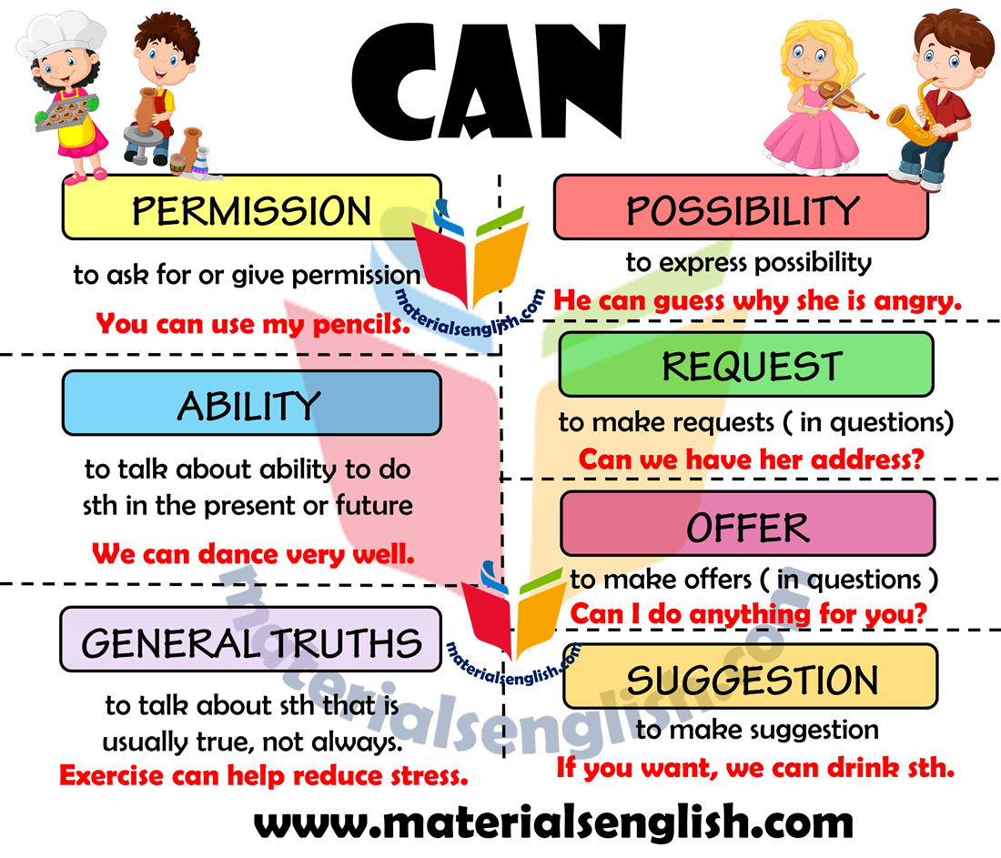  Ex:1 P: 55  Ask students to open their books at page 55 and copy the chart into their notebooks.  Students to work alone to complete the chart. Encourage them to underline the grammatical forms they are learning when writing example sentences in their notebooks. | Students of the class are listed.  Students' attention is drawn to the lesson.  Learners remember previous lesson vocabulary  Determines the topic and purpose of the lesson  Students say different words from the picture  Pupils complete the examples from the text.  ANSWERS  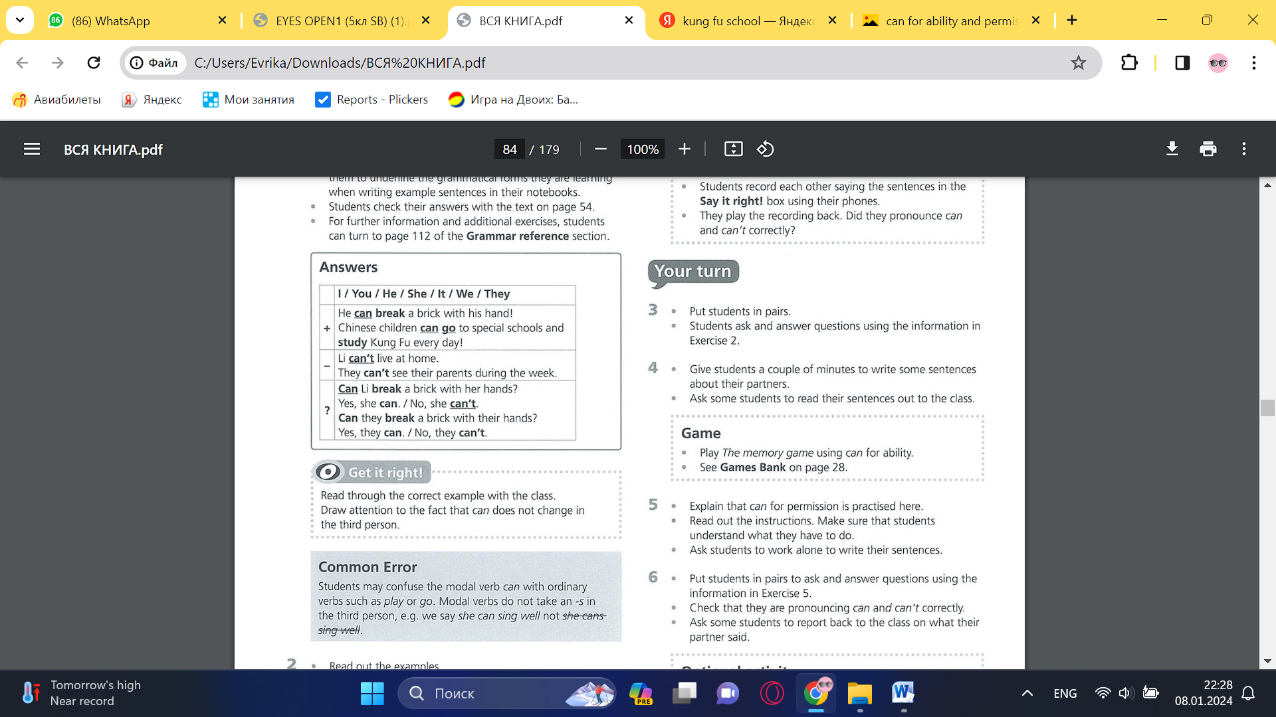 | The teacher to assess learners for their ability.  “Good job!  Well done!”  Formative Assessment  Good job!  Descriptor:  - complete the examples  Total: 1 point
 | Students check their answers with the text on page 54. For further information and additional exercises, students can turn to page 112 of the Grammar reference section  Ex: 2 P: 55  Read out the examples.  Students choose four ideas from the list to write sentences about and write further sentences using their own ideas.  Students work alone to write their sentences.  Monitor while students do this. Help as necessary.  Ex: 3 P: 55  Put students in pairs.  Students ask and answer questions using the information in Exercise 2  Ex: 4 P: 55  Give students a couple of minutes to write some sentences about their partners.  Ask some students to read their sentences out to the class  Differentiation: «Verbal support» method is used to help Ss use new words in the sentences. | Pupils complete the examples with can and can’t. use the ideas below and add your own ideas.  ANSWERS  2 can  3 can't  4 can  5 Can  Pupils work with a partner. Ask and answer the question.  ANSWERS  Students own answer  Pupils write sentences about your partner’s ability.  ANSWERS  Students own answer | Descriptor:  - complete the examples  - add your own ideas.  Total: 2 point  Descriptor:  - complete the examples  - add your own ideas.  Total: 2 point  Descriptor:  - work with a partner.  - ask and answer the question  Total: 2 point  -Make CCQ questions Yes / No  Total: 1 point
End of the lesson  5 min | FEEDBACK  Learners provide feedback on what they have learned at the lesson.  Ex:  Home task: | Ss evaluate each other and encourage classmate with phrases like:  Well done! Brilliant! Good job! I like it! |  | Poster Success

Short term plan: term 3

Unit 5: Creativity |  | Lesson 52
Teacher name:

Date:
Grade: 5 |  | Number present: | absent:
Lesson title | Listening: A podcast
Learning objectives | 5. 3. 4. 1 respond in sentences with some flexibility to unexpected comments on a variety of general and academic topics;  5. 5. 4. 1 write long sentences in paragraph size with the teacher's support to provide personal information;
Lesson objectives | Learners will be able to:  - listen to a boy talking about his school.  - learn vocabulary for types of music.  - talk about types of music
Value links | "Law and Order"  Know the basics of the legal system and human rights
Plan

Stages / Time | Teachers actions | Students actions | Assessment criteria | Resources
Beginning of the lesson  5 min  Middle of the lesson  Presentation part.  35 min | Organization moment :  1.Greeting.  Ask about the weather.  The teacher sets the lesson objectives, letting students know what to anticipate from the lesson.  Warming up  revise the language from the previous lesson  Lead – In    Ex:1 P:30  Ask students to look at the photos on page 56 or put them on the interactive whiteboard. Ask students to describe the photos.  Put students in pairs to ask and answer the question. | Students of the class are listed.  Students' attention is drawn to the lesson.  • Learners talk about daily routines previous lesson vocabulary  Determines the topic and purpose of the lesson  Students say different words from the picture  Pupils look at the New Bank School website. Answer the question.  ANSWERS  Students own answer | The teacher to assess learners for their ability.  “Good job!  Well done!”  Formative Assessment  Good job!  Descriptor:  - look at the New Bank School website  - answer the question  Total: 2 point
 | Ex: 2 P: 30  Read out the question. Ask students to guess what the answer is.  Play the recording. Encourage students to listen for key words in a recording.  Check answer. Find out which students guessed correctly  Ex: 3 P: 30  Give students time to read through the gap sentences.  Play the recording again.  Students listen to it and complete the sentences.  Check answers.  Differentiation: «Verbal support» method is used to help Ss use new words in the sentences.  Ex: 4 P: 30  Books closed. Elicit types of music students know. Write the words on the board.  Ask students to look at the list of the types of music in the box on page 56.  Students work in pairs to match the words in the box with the pictures.  Play the recording. Students listen to it, check their answers, and repeat the words. | Pupils listen to Tom talking about the school. Answer the question.  ANSWERS  Dance.  Pupils listen again. Complete the information.  ANSWERS  2 4 pm  3 three  4 morning  5 dancer  .  Pupils match the school subjects in the box with the pictures.  ANSWERS  a opera  b rock  c jazz  d pop  e classical  f soul  g hip-hop  h rap  i folk | Descriptor:  - listen to Tom  - answer the question  Total: 2 point  Descriptor:  - listen again  - complete the information  Total: 2 point  Descriptor:  - match the school subjects  Total: 1 point  -Make CCQ questions Yes / No  Total: 1 point | Card  Worksheet  Students book
End of the lesson  5 min | FEEDBACK  Learners provide feedback on what they have learned at the lesson.  Ex:  Home task: | Ss evaluate each other and encourage classmate with phrases like:  Well done! Brilliant! Good job! I like it! |  | Poster Success

Short term plan: term 3

Unit: 5 Creativity |  | Lesson 53
Teacher name:

Date:
Grade:5 |  | Number present: | absent:
Lesson title | Language focus: Object pronouns
Learning objectives | 5. 3. 1. 1 provide basic information about oneself and others at the sentence level within a number of general topics;  5. 4. 2. 1 understand specific information in simple, short texts on a number of general and educational topics with little help from the teacher;
Lesson objectives | Learners will be able to:  - learn object pronouns.  - learn (don't) like, don't mind, love, hate + -ing  - talk about what I like and dislike
Value links | "Law and Order"  Observance of norms and rules of order and justice understand the need
Plan

Stages / Time | Teachers actions | Students actions | Assessment criteria | Resources
Beginning of the lesson  5 min  Middle of the lesson  Presentation part.  35 min | Organization moment :  1.Greeting.  Ask about the weather.  The teacher sets the lesson objectives, letting students know what to anticipate from the lesson.  Warming up  Revise the vocabulary from the previous lesson  Lead – In  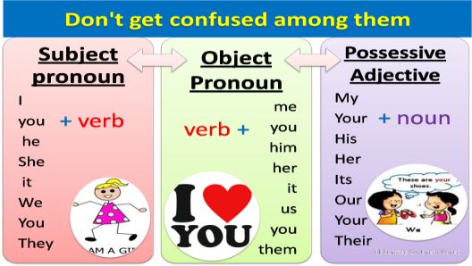  Ex:1 P:57  Explain that the gapped sentences are from the listening on page 56.  Students to copy and complete the sentences with object pronouns. Help weaker students by pointing out that the object pronoun forms can be seen in the box in Exercise 2.  Play the recording for students to check their answers. | Students of the class are listed.  Students' attention is drawn to the lesson.  Learners talk about days of the week previous lesson vocabulary  Determines the topic and purpose of the lesson  Students say different words from the picture  Pupils complete the examples from the listening.  ANSWERS  1 me  2 it  3 them  4 him  5 us | The teacher to assess learners for their ability.  “Good job!  Well done!”  Formative Assessment  Good job!  Descriptor:  - complete the examples  Total: 1 point | Pictures
 | Ex: 2 P: 57  Students work in pairs to complete this matching exercise.  Check answers.  For further information and additional exercises, students can turn to page 112 of the Grammar reference section.  Ex: 3 P: 57  Read out the sentences. Ask students the question.  Elicit that the second verb in each sentence has the -ing ending.  For further information and additional exercises, students can turn to page 112 of the Grammar reference section.  Ex: 4 P: 57  Read out the example sentence.  Students work alone to complete the exercise.  Remind students to use the -ing ending and pay attention to which verbs are in the third person singular and so require an -s ending.  Check answers. | Pupils match the object pronouns in the box with the subject pronouns.  ANSWERS  You-you  it-it  he-him  she-her  we-us  they-them  you – you  Pupils look at the sentences from the listening. Answer the question.  ANSWERS  -ing ending  Pupils write complete sentences that are true for you.  ANSWERS  Students own answer. | Descriptor:  - work in pairs  - match the object pronouns in the box  Total: 2 point  Descriptor:  - read out the sentences  - answer the question.  Total: 2 point  Descriptor:  - write complete sentences  Total: 2 point  -Make CCQ questions Yes / No
End of the lesson  5 min | FEEDBACK  Learners provide feedback on what they have learned at the lesson.  Ex:  Home task: | Ss evaluate each other and encourage classmate with phrases like:  Well done! Brilliant! Good job! I like it! |  | Poster Success

Short term plan: term 3

Unit 5 Creativity |  | Lesson 54
Teacher name:

Date:
Grade: 5 |  | Number present: | absent:
Lesson title | Discovery culture
Learning objectives | 5. 2. 6. 1 to determine a number of general and educational topics with the support of meaning from the context of a short conversation;  5. 3. 1. 1 provide basic information about oneself and others at the sentence level within a number of general topics;  5. 5. 1. 1 plan, write, correct and check text-level works on some general and academic topics;
Lesson objectives | Learners will be able to:  - watch a video about a schoolgirl from South Africa.  - compare my school day to the schoolgirl's.
Value links | "Law and Order"  Ensuring the protection and safety of society understand the importance of law and order as
Plan

Stages / Time | Teachers actions | Students actions | Assessment criteria | Resources
Beginning of the lesson  5 min  Middle of the lesson  Presentation part.  35 min | Organization moment :  1.Greeting.  Ask about the weather.  The teacher sets the lesson objectives, letting students know what to anticipate from the lesson.  Warming up  Revise the language of the previous lesson.  Lead – In    Ex:1 P:58  Ask students to open their books at page 58.  Use the interactive whiteboard, focus students' attention on the map and photographs, and elicit answers to the two questions. | Students of the class are listed.  Students' attention is drawn to the lesson.  Determines the topic and purpose of the lesson  Learners talk about favourite dayprevious lesson vocabulary  Students say different words from the picture and count one to hundred  Pupils look at the map and the picture. Answer the question.  ANSWERS  Nelson Mandela, South Africa | The teacher to assess learners for their ability.  “Good job!  Well done!”  Formative Assessment  Good job!  Descriptor:  - look at the map  - answer the question.  Total: 2 point
 | Ex: 2 P: 58  Read out the three questions Put students into pairs and ask them to guess answers  Ex: 3 P: 58  Play the video so that students can check their answers to Exercise 2  Ex: 4 P: 58  Give weaker students a of the script which they then read they watch the  Video  Ex:5 P:58  Give students a minute to read the gapped profile.  Play the video.  Students watch and complete the gaps.  Ex: 6 P: 58  Ask students to work in pairs to try to complete the captions.  Ex: 7 P: 58  Play the video for students to check their answers to Exercise 6. | Pupils look at the pictures of Tobilay and answer the question.  ANSWERS  Students own answer.  Pupils watch the video up to 0.38 and check your answers  ANSWERS  1 She's at school.  2 She's 14 years old.  3 She's from South Africa  Pupils mark the statements. Correct the false ones.  ANSWERS  1 F (The school children wear blue shirts.)  2 F (They have rice for lunch.)  3T  4T  5 F (Tobilay does her homework at home.)  Pupils watch video again and complete Tobilay’s profile.  ANSWERS  1 14  2 5  3 8  4 sings  5 history  6 songs  7 dances  8 dancing  9 homework  10 notebook  11 notes  12 homework  Pupils look at the pictures. Complete the captions about South African cultures.  ANSWERS  Students own answer.  Pupils watch the video again to check your answers  ANSWERS  a birthday b 5 c songs, dance | Descriptor:  - Pupils look at the pictures of Tobilay  - answer the question.  Total: 2 point  Descriptor:  - watch the video  - check your answers  Total: 2 point  Descriptor:  - mark the statements  - correct the false ones.  total: 3 point  -Make CCQ questions Yes / No  Descriptor:  - watch video again  - complete Tobilay’s profile.  Total: 2 point  Descriptor:  - look at the pictures  - Complete the captions  Total: 2 point  Descriptor:  - watch the video  - check your answers  Total: 2 point
End of the lesson  5 min | FEEDBACK  Learners provide feedback on what they have learned at the lesson.  Ex:  Home task: | Ss evaluate each other and encourage classmate with phrases like:  Well done! Brilliant! Good job! I like it! |  | Poster Success

Short term plan: term 3

Unit 5 Creativity |  | Lesson 55
Teacher name:

Date:
Grade: 5 |  | Number present: | absent:
Lesson title | Reading: A profile
Learning objectives | 5. 3. 3. 1 express an opinion in a sentence within the framework of a number of general and educational topics;  5. 5. 3. 1 write specific details with the support of the teacher, describing people, places and objects at the text level;
Lesson objectives | Learners will be able to:  -read a profile of a school in Wales.  - learn some adjectives opposites
Value links | "Law and Order"  Know the basics of the legal system and human rights
Plan

Stages / Time | Teachers actions | Students actions | Assessment criteria | Resources
Beginning of the lesson  5 min  Middle of the lesson  Presentation part.  35 min | Organization moment :  1.Greeting.  Ask about the weather.  The teacher sets the lesson objectives, letting students know what to anticipate from the lesson.  Warming up  Revise the language of the previous lesson.  Lead – In  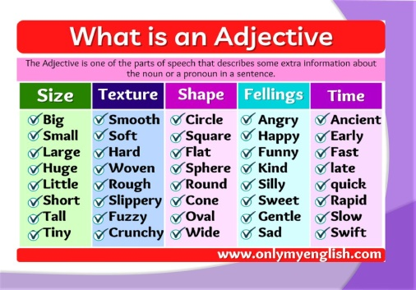  Ex:1 P:59  Ask students to open their books at page 59.  Use the interactive whiteboard to show students the map of the British Isles.  Put students in pairs to identify Wales on the map (it's to the west of England) and say what activities they think students in Wales can do.  Check answers. | Students of the class are listed.  Students' attention is drawn to the lesson.  Determines the topic and purpose of the lesson  Learners talk about favourite dayprevious lesson vocabulary  Students say different words from the picture and count one to hundred  Pupils look at the map and photos. Answer the question.  ANSWERS  Wales is to the west of England.  guitar club,  hip-hop group,  rugby club,  surf club | The teacher to assess learners for their ability.  “Good job!  Well done!”  Formative Assessment  Good job!  Descriptor:  - look at the map  - answer the question.  Total: 2 point | Pictures
 | Ex: 2 P: 59  Tell students to cover the profile.  Ask: What can you remember from Gareth's profile?  Students can then look at the profile to check their ideas.  Check answers with the class.  Refer students to the information in the FACT! box.  Ex: 3 P: 59  Identify which adjectives mean very good with the class.  You could then write synonym on the board and explain that it refers to words with the same or similar meaning such as brilliant and great.  To extend this work, ask students to turn to the Vocabulary bank on page 120 and do the Adjectives activities.  Ex: 4 P: 59  Ask students to work alone to do this exercise.  Students can then compare answers in pairs before you check answers with the class.  Encourage students to read the article again and make a note of an idea or a fact in it that interests them. They can then share this with a partner. | Pupils read the profile again and complete the sentences.  ANSWERS  1 Gareth speaks two languages, English and Welsh. He speaks Welsh with his family. He goes to the Surf Club. He can swim fast. He loves surfing.  2 Isabel goes to the Guitar Club. She loves playing music and singing.  3 Darren goes to the Rugby Club. He can run very fast  Pupils find these adjectives in the text. Answer the question.  ANSWERS  great,  brilliant  Pupils find the opposites for these adjectives.  ANSWERS  b terrible  c slow | Descriptor:  - read the profile  - complete the captions  Total: 2 point  Descriptor:  - find these adjectives  - answer the question  Total: 2 point  Descriptor:  - find the opposites for these adjectives  total: 1 point  -Make CCQ questions Yes / No  Total: 10 point | Card  Worksheet  Students book
End of the lesson  5 min | FEEDBACK  Learners provide feedback on what they have learned at the lesson.  Ex:  Home task: | Ss evaluate each other and encourage classmate with phrases like:  Well done! Brilliant! Good job! I like it! |  | Poster Success

Short term plan: term 3

Unit 5 Creativity |  | Lesson 56
Teacher name:

Date:
Grade: 5 |  | Number present: | absent:
Lesson title | Speaking: Asking and giving permission
Learning objectives | 5. 3. 4. 1 respond in sentences with some flexibility to unexpected comments on a variety of general and academic topics;  5. 4. 2. 1 understand specific information in simple, short texts on a number of general and educational topics with little help from the teacher;
Lesson objectives | Learners will be able to:  - watch or listen to teenagers talking about using their mobile phones at school.  - practise asking for and giving permission.
Value links | "Law and Order"  Observance of norms and rules of order and justice understand the need
Plan

Stages / Time | Teachers actions | Students actions | Assessment criteria | Resources
Beginning of the lesson  5 min  Middle of the  lesson  Presentation part.  35 min | Organization moment :  1.Greeting.  Ask about the weather.  The teacher sets the lesson objectives, letting students know what to anticipate from the lesson.  Warming up  Revise the language of the previous lesson.  Lead – In  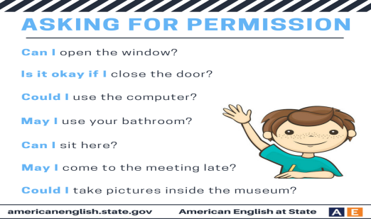  Ex: 1 P: 60  Tell students they are going to watch some teenagers answering the following question: Can you use your mobile phone at school?  Read out the three questions and then play the video.  Students work alone to answers the questions. They can compare answers in pairs before you check answers with the class | Students of the class are listed.  Students' attention is drawn to the lesson.  Determines the topic and purpose of the lesson  Learners talk about favourite dayprevious lesson vocabulary  Students say different words from the picture and count one to hundred  Pupils watch the teenagers in the video. Answer the question.  ANSWERS  a none  b one  c three | The teacher to assess learners for their ability.  “Good job!  Well done!”  Formative Assessment  Good job!  Descriptor:  - watch the teenagers in the video  - answer the question.  Total: 2 point | Pictures
 | Ex:2 P:60  Ask students to work in pairs to ask and answer the question. Encourage them to ask additional questions, e.g. What do you like most about your phone? How many texts do you send a day?  Ask some students to report back to the class on what their partner said.  To extend this activity, you could then ask the class: Are mobiles in class a good or a bad idea?  Ex: 3 P: 60  Give students time to read the question, then play the recording.  Students can compare answers in pairs before you check the answer  Ex: 4 P: 60  Ask stronger students try to complete the conversation without looking at the phrases in the Useful language box  Ex: 5 P: 60  Play the recording for students to check their answers to Exercise 4 | Pupils ask and answer with your partner.  ANSWERS  Students own answer  Pupils listen to the conversation. Answer the question.  ANSWERS  Students own answer  Pupils complete the conversation with the useful language.  ANSWERS  Students own answer  Pupils listen again and check your answers  ANSWERS  1 Can 1  2 sorry, I'm afraid you can't  3 Why not?  4 Can we  5 Yes, you can  6 Great, thanks | Descriptor:  - ask and answer with your partner  Total: 2 point  Descriptor:  - complete the conversation with the useful language.  - answer the question  Total: 2 point  Descriptor:  - listen again and check your answers  total: 1 point  -Make CCQ questions Yes / No  Total: 10 point | Card  Worksheet  Students book
End of the lesson  5 min | FEEDBACK  Learners provide feedback on what they have learned at the lesson.  Ex:  Home task: | Ss evaluate each other and encourage classmate with phrases like:  Well done! Brilliant! Good job! I like it! |  | Poster Success

Short term plan: term 3

Unit 5 Creativity |  | Lesson 57
Teacher name:

Date:
Grade: 5 |  | Number present: | absent:
Lesson title | Writing: an email
Learning objectives | 5. 3. 3. 1 express an opinion in a sentence within the framework of a number of general and educational topics;  5. 4. 2. 1 understand specific information in simple, short
Lesson objectives | Learners will be able to:  - read an email.  - learn informal language used in emails.  - write an email about my school
Value links | "Law and Order"  Ensuring the protection and safety of society understand the importance of law and order as
Plan

Stages / Time | Teachers actions | Students actions | Assessment criteria | Resources
Beginning of the lesson  5 min  Middle of the  lesson  Presentation part.  35 min | Organization moment :  1.Greeting.  Ask about the weather.  The teacher sets the lesson objectives, letting students know what to anticipate from the lesson.  Warming up  Revise the language of the previous lesson.  Lead – In  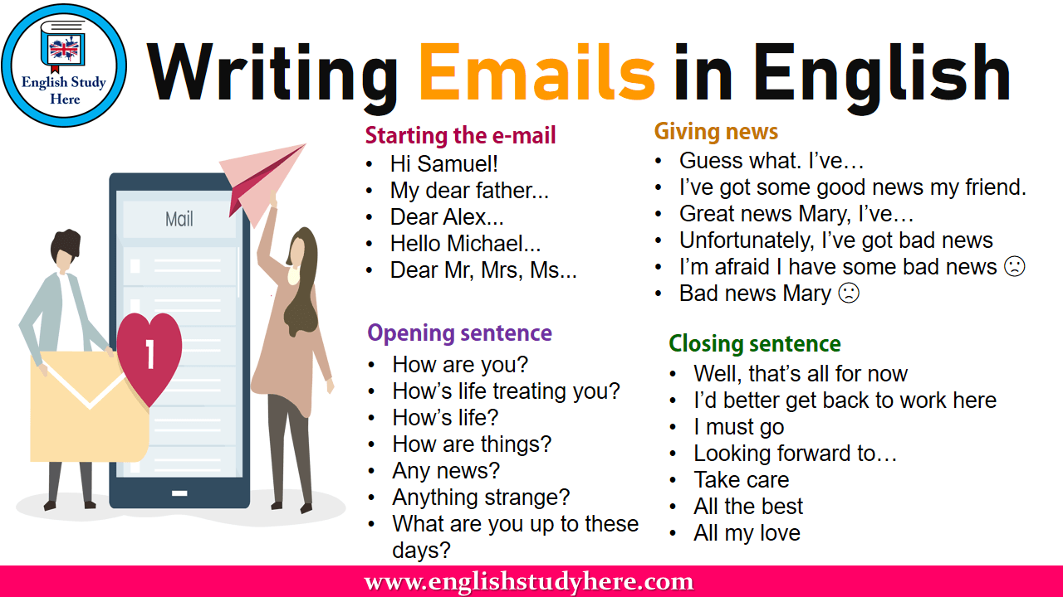  Ex: 1 P: 61  Ask students to open their books at page 61 and read Günter's and Anna's emails.  Elicit answer to the question from the class. | Students of the class are listed.  Students' attention is drawn to the lesson.  Determines the topic and purpose of the lesson  Learners talk about favourite dayprevious lesson vocabulary  Students say different words from the picture and count one to hundred  Pupils read Anna’s reply to Gunter. Answer the question.  ANSWERS  Her school is in London, England. It's small | The teacher to assess learners for their ability.  “Good job!  Well done!”  Formative Assessment  Good job!  Descriptor:  - read Anna’s reply  - answer the question.  Total: 2 point | Pictures
 | Ex:2 P:61  Put students into small groups and tell them to close their books.  Read out the questions and see how many students can answer from memory.  Students can then uncover the email and check their answers.  Ex: 3 P: 61  Write formal/informal language on the board and check that students understand the difference between the two.  Ask students to find further examples of informal language to add to the Useful language box..  Check answers,  Ex: 4 P: 61  Go through the first sentence with the whole class as an example.  Students can then work alone or in pairs to rewrite the sentences so that they are more informal.  Check answers. | Pupils answer the question about Anna’s school.  ANSWERS  1 Carlton Arts School  2 They're from 11 to 18 years old.  3 There are about 40 teachers.  4 It finishes at 3.30 pm.  5 She has 11 subjects.  6 She has a Drama class every day.  Pupils find examples of informal language In Anna’s email.  ANSWERS  to start: Hey  to end: Bye for now! contractions: It's, school's  Pupils complete the useful language box with the phrases.  ANSWERS  1 Hi Anna, /Hey Anna,  2 I've got some info for you.  3 Here's a photo of my school.  4 Music's my best subject and our teacher's great.  5 That's all for now. Bye!, Günter / Bye for now! Günter | Descriptor:  - answer the question  Total: 1 point  Descriptor:  - find examples of informal language  Total: 2 point  Descriptor:  - find examples of informal language  total: 1 point  -Make CCQ questions Yes / No  Total: 10 point | Card  Worksheet  Students book
End of the lesson  5 min | FEEDBACK  Learners provide feedback on what they have learned at the lesson.  Ex:  Home task: | Ss evaluate each other and encourage classmate with phrases like:  Well done! Brilliant! Good job! I like it! |  | Poster Success

Short term plan: term 3

Unit 5 Creativity |  | Lesson 58
Teacher name:

Date:
Grade: 5 |  | Number present: | absent:
Lesson title | CLIL: Art Images and communication
Learning objectives | 5.2.8.1 understand supported narratives, including some extended talk, on an increasing range of general and curricular topics  5.4.3.1 understand the detail of an argument on a limited range of familiar general and curricular topics;  5.5.6.1 link, with some support, sentences into coherent paragraphs using basic connectors on a limited range of familiar general topics;
Lesson objectives | Learners will be able to:  - read about the use of images to communicate a message.  - talk about the communicative purpose of images in your school
Value links | "Creativity and Innovation"  Monitoring, measuring, conducting experiments and experiments ability;
Plan

Stages / Time | Teachers actions | Students actions | Assessment criteria | Resources
Beginning of the lesson  5 min  Middle of the  lesson  Presentation part.  35 min | Organization moment :  1.Greeting.  Ask about the weather.  The teacher sets the lesson objectives, letting students know what to anticipate from the lesson.  Warming up  Revise the language of the previous lesson.  Lead – In    Ex: 1 P: 62  Ask students to open their books at page 62.  Put students into pairs. Ask them to communicate the information in the sentences to each other using a gesture, a sound and an image.  Check if the ideas are shared by most students. | Students of the class are listed.  Students' attention is drawn to the lesson.  Determines the topic and purpose of the lesson  Learners talk about favourite dayprevious lesson vocabulary  Students say different words from the picture and count one to hundred  Pupils work with a partner. Look at the sentences and communicate the information.  ANSWERS  Students own answer | The teacher to assess learners for their ability.  “Good job!  Well done!”  Formative Assessment  Good job!  Descriptor:  - work with a partner  - communicate the information  Total: 2 point | Pictures
 | Ex:2 P:62  Read out the three categories. Make sure students understand the difference between them. Use L1 to explain that the category titles are not standard phrases used in everyday conversation, but a way of organising the ideas about how images communicate messages in different ways.  Check students' understanding of the following vocabulary: inform, clear, persuasive, entertain.  Ex: 3 P: 62  Read out the words in the box.  Make sure that students understand the type of image that each word refers to.  Play the recording.  Students can compare answers in pairs before you check answers with the class  Ex: 4 P: 62  •If appropriate, ask students to walk around the school in pairs during class time, making a list of images they see and a note of what communicative purpose those images have. Alternatively, you could take photos of some schools signs and print them for the class. Students could then guess in which part of the school these signs can be found. If you are not able to do this, set this activity for homework Students can share their ideas in the next lesson | Pupils read the text. Match the images with their communicative purpose.  ANSWERS  A 2 B 3 C 1  Pupils listen to the conversation. Answer the question.  ANSWERS  logo  map  poster  sign  Pupils work with a partner. Look at images in your school.  ANSWERS  Students own answer | Descriptor:  - read the text  - match the images with their communicative  Total: 1 point  Descriptor:  - listen to the conversation  - answer the question.  Total: 2 point  Descriptor:  - work with a partner  - look at images in your school  total: 1 point  -Make CCQ questions Yes / No  Total: 10 point | Card  Worksheet  Students book
End of the lesson  5 min | FEEDBACK  Learners provide feedback on what they have learned at the lesson.  Ex:  Home task: | Ss evaluate each other and encourage classmate with phrases like:  Well done! Brilliant! Good job! I like it! |  | Poster Success

Short term plan: term 3

Unit 5 Creativity |  | Lesson 59
Teacher name:

Date:
Grade: 5 |  | Number present: | absent:
Lesson title | Extra reading: making music  Summative assessment for the unit ” Creativity”
Learning objectives | 5. 2. 8. 1 supported understanding of general and academic topics in a range of longer conversations, including stories  5. 4. 3. 1 to understand the evidence in the context of some familiar general and academic topics;  5. 5. 6. 1 logically combine
Lesson objectives | Learners will be able to:  - talk about the communicative purpose of images in your school
Value links | "Creativity and Innovation"  Ability to find optimal ways to solve educational tasks to use new and already familiar algorithms combining, using them in solving non-standard problems
Plan

Stages / Time | Teachers actions | Students actions | Assessment criteria | Resources
Beginning of the lesson  5 min  Middle of the  lesson  Presentation part.  35 min | Organization moment :  1.Greeting.  Ask about the weather.  The teacher sets the lesson objectives, letting students know what to anticipate from the lesson.  Warming up  Revise the language of the previous lesson.  Lead – In  Ex: 1 P: 63  Check students' understanding of poet and perform. Once students have read the text, refer them to questions 1-7. Check that students understand these questions befor they do the task.  Students can compare answers in pairs before you check them with the class. | Students of the class are listed.  Students' attention is drawn to the lesson.  Determines the topic and purpose of the lesson  Pupils read the text, then answer the question  ANSWERS  1 They like/ love all kinds of music.  2 in streets and parks in many cities in Kazakhstan. | The teacher to assess learners for their ability.  “Good job!  Well done!”  Formative Assessment  Good job! | Pictures
 | Summative assessment for the unit ” Creativity”  Conclusion during the lesson some tasks differentiated by outcomes of the students and by their abilities. | 3 No, they don't. They happen in Europe too.  4 Every day.  5 About anything, for example, family and animals, the land, mountains, ideas and feelings.  6 They perform in concerts and singing competitions.  7 They are on TV every Sunday. | Descriptor:  - read the text  - answer the question  Total: 2 point  -Make CCQ questions Yes / No  Total: 10 point | Card  Worksheet  Students book
End of the lesson  5 min | FEEDBACK  Learners provide feedback on what they have learned at the lesson.  Ex:  Home task: | Ss evaluate each other and encourage classmate with phrases like:  Well done! Brilliant! Good job! I like it! |  | Poster Success

Short term plan: term 3

Unit 6 Reading for pleasure |  | Lesson 60
Teacher name:

Date:
Grade: 5 |  | Number present: | absent:
Lesson title | Arthur Conan Doyle’s biography
Learning objectives | 5. 2. 4. 1 to understand general and educational topics in a long conversation with the support of the main ideas;  5. 4. 1. 1 understand the main idea of ​​some simple short texts on general and educational topics;
Lesson objectives | Learners will be able to:  • read a biography of Arthur Conan Doyle.  •speak about Arthur Conan Doyle.
Value links | "Creativity and Innovation"  Use of various cognitive tools, knowledge about the world be able to collect (linguistic, reading culture, information, service in the digital environment)
Plan

Stages / Time | Teachers actions | Students actions | Assessment criteria | Resources
Beginning of the lesson  5 min  Middle of the  lesson  Presentation part.  35 min | Organization moment :  1.Greeting.  Ask about the weather.  The teacher sets the lesson objectives, letting students know what to anticipate from the lesson.  Warming up  Revise the language of the previous lesson.  Lead – In  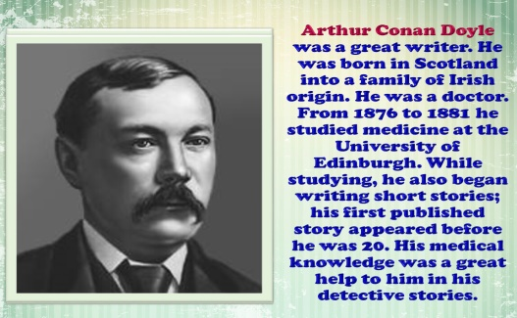  Ex: 1 P: 64  Ask students to open their books at page 65. Focus their attention on the illustration and the photograph of Arthur  Conan Doyle.  Ask students to read the biography quickly to find out which characters Doyle created. | Students of the class are listed.  Students' attention is drawn to the lesson.  Determines the topic and purpose of the lesson  Students say different words from the picture and count one to hundred  Pupils you are going to study part of a story by the British writer, Arthur Conan Doyle. Read the text about his life. Which famous characters did he write about? Do you know anything more about them?  ANSWERS  Sherlock Holmes and Doctor Watson | The teacher to assess learners for their ability.  “Good job!  Well done!”  Formative Assessment  Good job!  Descriptor:  - read the text  - answer the question  Total: 2 point | Pictures
 | Check students' understanding of the biography by asking some comprehension questions about it, e.g. When was Doyle born? (1859.) Where was Doyle born? (Edinburgh.) What did he study at university? (Medicine - he wanted to be a doctor.) When did he write his first story about Holmes and Watson? (1886.) How many stories did he write about these characters? (56.) When did Doyle die? (1930.)  Ex: 1 P: 64  Write The Hound of the Baskervilles on the board. Tell students that this is one of Doyle's most famous stories.  Explain that a hound is a type of dog used for hunting. Drill the pronunciation of the word: /haund/. Explain that the Baskervilles are a family, and they are characters in the story. Drill the pronunciation: /baskavılz/.  Before students read the extract from the story, read out the information in the Get reading box. Tell students that reading quickly to get a general sense of the meaning of a text is called skim reading or reading for gist. Elicit why it is such an important skill - because we do not always have time to read slowly; being able to skim read well is particularly useful in exams.  Read out the types of story in the box. Make sure students understand the differences. You can check students' understanding by eliciting examples of each type of story.  . Check answers. | Pupils in this text Doctor Watson is telling the story. Read the first part of the text quickly (lines 1-17). What kind of story is it?  ANSWERS  A mystery story | Descriptor:  - read the text  - answer the question  Total: 2 point  -Make CCQ questions Yes / No  Total: 10 point | Card  Worksheet  Students book
End of the lesson  5 min | FEEDBACK  Learners provide feedback on what they have learned at the lesson.  Ex:  Home task: | Ss evaluate each other and encourage classmate with phrases like:  Well done! Brilliant! Good job! I like it! |  | Poster Success

Short term plan: term 3

Unit 6 Reading for pleasure |  | Lesson 61
Teacher name:

Date:
Grade: 5 |  | Number present: | absent:
Lesson title | Reading a story
Learning objectives | 5. 3. 3. 1 express an opinion in a sentence within the framework of a number of general and educational topics;  5. 4. 5. 1 identify the main idea from the context of short texts within the framework of some familiar general and educational topics;
Lesson objectives | Learners will be able to:  • read a biography of Arthur Conan Doyle.  •speak about Arthur Conan Doyle.
Value links | "Creativity and Innovation"  Monitoring, measuring, conducting experiments and experiments ability;
Plan

Stages / Time | Teachers actions | Students actions | Assessment criteria | Resources
Beginning of the lesson  3 min  Middle of the  lesson  Presentation part.  35 min | Organization moment :  1.Greeting.  Ask about the weather.  The teacher sets the lesson objectives, letting students know what to anticipate from the lesson.  Warming up  Revise the language of the previous lesson.  Lead – In  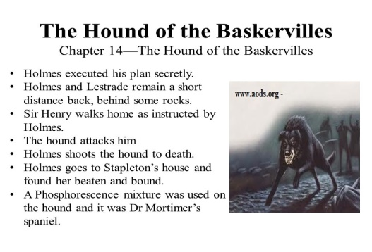  Ex: 2 P: 65  Read out the questions. Check students' understanding of the word huts. Note that there is a translation of this word underneath the extract on page 65.  Ask students to work alone to answer the questions. | Students of the class are listed.  Students' attention is drawn to the lesson.  Determines the topic and purpose of the lesson  Students say different words from the picture and count one to hundred  Pupils answer the question  ANSWERS  1 A person/stranger  2. Yes, he found a message about him. | The teacher to assess learners for their ability.  “Good job!  Well done!”  Formative Assessment  Good job!  Descriptor:  - read the text  - answer the question  Total: 2 point | Pictures
 | They can compare answers in pairs before you check answers with the class.  When you check answers, ask students to say which part of the text gave them the answers.  Ex: 3 P: 65  Read out the three questions. Check students' understanding of moor and enemy. Note that there is a translation of moor underneath the extract on page 65. Your enemy is someone you dislike, who is on a different side to you in a conflict, competition or battle of some kind.  Give students a few minutes to discuss the questions in pairs.  Elicit answers to the questions, but do not confirm any ideas at this stage. | Pupils work with a partner. Ask and answer the questions  ANSWERS  Students own answer. | Descriptor:  - work with a partner  - answer the question  Total: 2 point  -Make CCQ questions Yes / No  Total: 10 point | Card  Worksheet  Students book
End of the lesson  5 min | FEEDBACK  Learners provide feedback on what they have learned at the lesson.  Ex:  Home task: | Ss evaluate each other and encourage classmate with phrases like:  Well done! Brilliant! Good job! I like it! |  | Poster Success

Short term plan: term 3

Unit 6 Reading for pleasure |  | Lesson 62
Teacher name:

Date:
Grade: 5 |  | Number present: | absent:
Lesson title | Reading: a biography
Learning objectives | 5. 1. 7. 1 systematic argumentation and confirmation in oral and written words;  5. 4. 5. 1 identify the main idea from the context of short texts within the framework of some familiar general and educational topics;
Lesson objectives | Learners will be able to:  • read a biography of Arthur Conan Doyle.  •speak about Arthur Conan Doyle.
Value links | "Creativity and Innovation"  Ability to find optimal ways to solve educational tasks to use new and already familiar algorithms combining, using them in solving non-standard problems
Plan

Stages / Time | Teachers actions | Students actions | Assessment criteria | Resources
Beginning of the lesson  Warming-up    5 min  Middle of the  lesson  Presentation part.  35 min | Organization moment :  1.Greeting.  Ask about the weather.  The teacher sets the lesson objectives, letting students know what to anticipate from the lesson.  Warming up  Revise the language of the previous lesson.  Lead – In  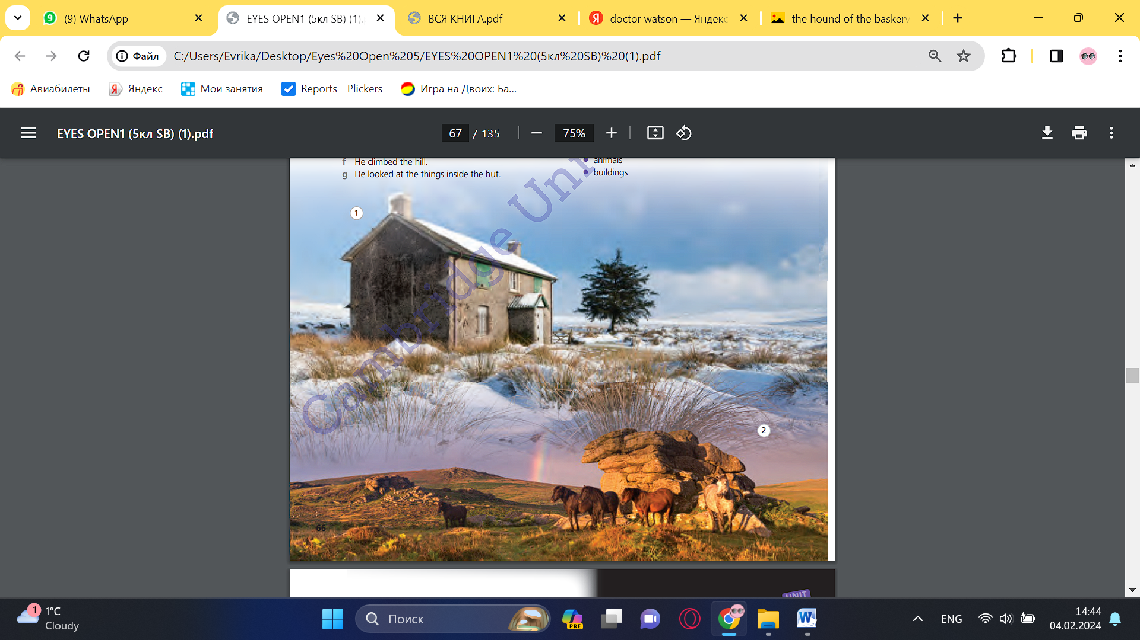  Ex: 4 P: 65  Read out the two questions, then ask students to read the next part of the story.  Students can compare their answers in pairs, before you check answers with the class as a whole. | Students of the class are listed.  Students' attention is drawn to the lesson.  Determines the topic and purpose of the lesson  Learners talk about favourite dayprevious lesson vocabulary  Students say different words from the picture and count one to hundred  Pupils read the next part of the text. Answer the question.  ANSWERS  I think the stranger is Holmes. I think Watson feels surprised and happy | The teacher to assess learners for their ability.  “Good job!  Well done!”  Formative Assessment  Good job!  Descriptor:  - read the text  - answer the question  Total: 2 point
 | Ex: 5 P: 65  Refer students to sentences a)-g). Explain that they are out of order. To help weaker students, you could show that f) is the first sentence and a) the second.  Students can work on this ordering exercise in small groups of three or four.  When you check answers, write the sentences up on the board in the correct order.  Ex: 6 P: 65  Ask students to describe the photographs, both of which show a moor. Put vocabulary on the board that will be useful in this exercise, e.g. building, snowy, grass, rocks, horses.  Read out the four items in the list, then ask students to work in pairs to make notes on how the two photos are similar to and differ from the descriptions of the moor in the text.  Check answers. Suggested answers are given below for the four points in Exercise 6, but students may identify further similarities and differences (e.g. time of day, hills, rocks, water, towers, smoke). | Pupils read the both parts of the text again. Then put these sentences about Doctor Watson in the correct order.  ANSWERS  a) He saw a small building. 2  b) He sat down in a corner. 6  c) He walked down the hill. 3  d) He checked that no one was inside the hut. 4  e) He heard someone coming. 7  f) He climbed the hill. 1  g), He looked at the things inside the hut. 5  Pupils work with a partner. Look at the photos. Answer the question.  ANSWERS  Photo 1  Similarities: it's sunny; there aren't any people or animals; there's a building  Differences: in the photo it's snowy, but in the text the grass is green; in the photo there's a house, but in the text there's a stone hut  Photo 2:  Similarities: it's sunny; the moor looks golden; the grass is green  Differences: in the photo there are horses, but in the text there's a bird; in the photo there aren't any buildings, but in the text there are stone huts | Descriptor:  - read the both parts of the text  - put these sentences in the correct order.  Total: 2 point  Descriptor:  - work with a partner  - answer the question.  Total: 2 point  -Make CCQ questions Yes / No  Total: 10 point | Card  Worksheet  Students book
End of the lesson  5 min | FEEDBACK  Learners provide feedback on what they have learned at the lesson.  Ex:  Home task: | Ss evaluate each other and encourage classmate with phrases like:  Well done! Brilliant! Good job! I like it! |  | Poster Success

Short term plan: term 3

Unit 6 Reading for pleasure |  | Lesson 63
Teacher name:

Date:
Grade: 5 |  | Number present: | absent:
Lesson title | Reading: a biography
Learning objectives | 5. 1. 7. 1 systematic argumentation and confirmation in oral and written words;  5. 4. 5. 1 identify the main idea from the context of short texts within the framework of some familiar general and educational topics;
Lesson objectives | Learners will be able to:  • read a biography of Arthur Conan Doyle.  •speak about Arthur Conan Doyle.
Value links | "Creativity and Innovation"  Use of various cognitive tools, knowledge about the world be able to collect (linguistic, reading culture, information, service in the digital environment)
Plan

Stages / Time | Teachers actions | Students actions | Assessment criteria | Resources
Beginning of the lesson  5 min  Middle of the  lesson  Presentation part.  35 min | Organization moment :  1.Greeting.  Ask about the weather.  The teacher sets the lesson objectives, letting students know what to anticipate from the lesson.  Warming up  Revise the language of the previous lesson.  Lead – In  Ex: 7 P: 66  Refer students to the true/false exercise.  Help weaker students by showing them how to determine whether or not a statement is false. For example, we know that the first statement is false because a sentence in paragraph A tells us | Students of the class are listed.  Students' attention is drawn to the lesson.  Determines the topic and purpose of the lesson  Students say different words from the picture and count one to hundred  Pupils mark the statements. Correct the false one.  ANSWERS  1 F (There were no other people, only a bird.)  2 F (He was excited to find the stranger.)  3 F (He didn't know if the stranger was inside or on the moor.).  4T | The teacher to assess learners for their ability.  “Good job!  Well done!”  Formative Assessment  Good job!  Descriptor:  - mark the statements  - correct the false one.  Total: 2 point | Pictures
 | that he was alone apart from a bird:  'He and I seemed to be the only living things between the blue sky and the empty land'.  Ask students to work in pairs to do the true/false task. Encourage them to read the text carefully to find the answers and remind them to correct the false sentences.  When you check the answers, ask students to point out the part of the text which led them to say that each of the statements was either true or false.  Ex: 8 P: 66  • Refer students to the definitions in 1-6.  Ask students to work alone to choose the correct definition for the underlined words in the story.  Students can compare their answers in pairs before you check answers with the class.  You can extend this activity by asking students to use these words in sentences of their own. This is a way of checking students' understanding of the vocabulary. Either elicit sentences from the class as a whole or ask students to work in pairs to come up with sentences. | 5 F (It was a message for someone else about Watson.)  6 F (It was a beautiful evening, but Watson didn't/couldn't relax and enjoy it.)  7 T  8T.  Pupils find the underlined words in the text and choose the correct meaning.  ANSWERS  1 a  2 a  3 b  4 b  5 a  6 b | Descriptor:  - find the underlined wor  - choose the correct meaning  Total: 2 point  -Make CCQ questions Yes / No  Total: 10 point | Card  Worksheet  Students book
End of the lesson  5 min | FEEDBACK  Learners provide feedback on what they have learned at the lesson.  Ex:  Home task: | Ss evaluate each other and encourage classmate with phrases like:  Well done! Brilliant! Good job! I like it! |  | Poster Success

Short term plan: term 3

Unit 7 Fantasy world |  | Lesson 64
Teacher name:

Date:
Grade: 5 |  | Number present: | absent:
Lesson title | Vocabulary: Places in a town
Learning objectives | 5. 3. 6. 1 to express one's thoughts clearly and concretely in sentences in pairs, groups and with the whole class;  5. 4. 5. 1 identify the main idea from the context of short texts within the framework of some familiar general and educational topics;
Lesson objectives | Learners will be able to:  -learn vocabulary for places in a town.  -ask and answer questions about my favourite place in town
Value links | "Creativity and Innovation"  Monitoring, measuring, conducting experiments and experiments  ability;
Plan

Stages / Time | Teachers actions | Students actions | Assessment criteria | Resources
Beginning of the lesson  5 min  Middle of the  lesson  Presentation part.  35 min | Organization moment :  1.Greeting.  Ask about the weather.  The teacher sets the lesson objectives, letting students know what to anticipate from the lesson.  Warming up  Revise the language of the previous lesson.  Lead – In  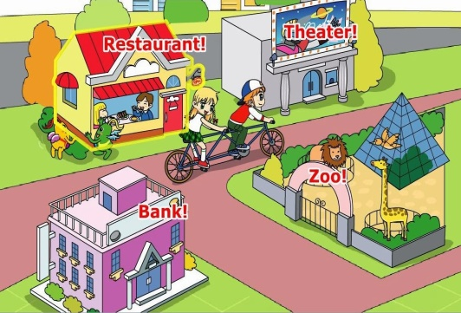  Ex: 1 P: 69  Ask students to open their books at page 69. Students describe what the people in the photos are doing, e.g. watching a football game, looking at bags. Then they work in pairs to do the matching exercise.  Play the recording.  Students listen to it and check their answers. | Students of the class are listed.  Students' attention is drawn to the lesson.  Determines the topic and purpose of the lesson  Students say different words from the picture and count one to hundred  Pupils match the pictures with the places in the box. Then listen, check and repeat.  ANSWERS  the sports center isn't in the photo  1 museum  2 shopping center  3 sports stadium  4 cinema  5 skate park  6 bowling alley  7 market | The teacher to assess learners for their ability.  “Good job!  Well done!”  Formative Assessment  Good job!  Descriptor:  - match the pictures with the places  - listen, check and repeat.  Total: 2 point | Pictures
 | Play the recording again for students to repeat the words. Pay particular attention to the pronunciation of museum which is /mju:'zrəm/ rather than /mju:'zerǝm/.  Ex: 2 P: 69  Play the recording.  Students identify the sounds and match them with the places pictured.  Students compare answers in pairs before you check answers with the class.  To extend the work on the vocabulary, you could ask students to divide the places into the following three groups: places where we buy things (shopping centre, market), places where we do or watch sports (sports stadium, bowling alley, sports centre, skate park) and cultural centres (museum, cinema). Students could also add some words in each category.  Ex: 3 P: 69  Read out each of the four questions in the chart and write your own answers to them on the board. Write notes rather than full sentences, e.g. every Saturday, with my friends, go to the cinema.  Give students a couple of minutes to copy and complete the chart with their own information. | Pupils listen to the sounds and match them with the places in the picture.  ANSWERS  1 sports stadium  2 cinema  3 shopping center  bowling alley  5 museum  6 market  7 skate park  Pupils copy and complete the table with information about you.  ANSWERS  Students own answer. | Descriptor:  - listen to the sounds  - match them with the places  Total: 2 point  Descriptor:  - copy and complete the table  - complete the chart with their own information.  Total: 2 point  -Make CCQ questions Yes / No  Total: 10 point | Card  Worksheet  Students book
End of the lesson  5 min | FEEDBACK  Learners provide feedback on what they have learned at the lesson.  Ex:  Home task: | Ss evaluate each other and encourage classmate with phrases like:  Well done! Brilliant! Good job! I like it! |  | Poster Success

Short term plan: term 3

Unit 7 Fantasy world |  | Lesson 65
Teacher name:

Date:
Grade: 5 |  | Number present: | absent:
Lesson title | Reading: An information text
Learning objectives | 5. 3. 6. 1 to express one's thoughts clearly and concretely in sentences in pairs, groups and with the whole class;  5. 4. 1. 1 understand the main idea of ​​some simple short texts on general and educational topics;
Lesson objectives | Learners will be able to:  - read a text about fantasy or reality.  - extreme adjectives.  - talk about historic places in my country
Value links | "Creativity and Innovation"  Ability to find optimal ways to solve educational tasks to use new and already familiar algorithms combining, using them in solving non-standard problems
Plan

Stages / Time | Teachers actions | Students actions | Assessment criteria | Resources
Beginning of the lesson  5 min  Middle of the  lesson  Presentation part.  35 min | Organization moment :  1.Greeting.  Ask about the weather.  The teacher sets the lesson objectives, letting students know what to anticipate from the lesson.  Warming up  Revise the language of the previous lesson.  Lead – In    Ex: 1 P: 70  Encourage all students to express their opinions.  Make sure students understand the meaning of the title and the difference between fantasy and reality | Students of the class are listed.  Students' attention is drawn to the lesson.  Determines the topic and purpose of the lesson  Students say different words from the picture and count one to hundred  Pupils look at the title. Answer the question.  ANSWERS  Students own answer. | The teacher to assess learners for their ability.  “Good job!  Well done!”  Formative Assessment  Good job!  Descriptor:  - look at the title  - answer the question  Total: 2 point | Pictures
 | Ex: 2 P: 70  Check students' understanding of the words introduced in the text by going through the text and asking questions, e.g. What is enormous? What place in your country, is ancient? What is rocky? If necessary, teach the phrase on the coast of, e.g. on the coast of north-west France. Encourage students to use context to help them work out the meaning of new words  Ex: 3 P: 70  Check weaker students' understanding of the following words from the text: enormous, ancient, levels, model, and rocky. Read out the four sentences.  Give students time to read the text again.  Check answers.  Ex: 4 P: 70  Ask: Do 'good' and 'brilliant' mean the same thing?  Explain that brilliant means very good and that it is an example of an extreme adjective, i.e. an adjective that intensifies or makes stronger the meaning of a 'normal' adjective such as good.  Ask students to find the four extreme adjectives in the text.  Ex: 5 P: 70  To help weaker students, complete the first example sentence with the class. Remind students the words are from Exercise 4.  Ask students to work in pairs to complete the sentences.  Check answers. | Pupils read the text. Check your ideas.  ANSWERS  Students own answer.  Pupils mark the statements. Correct the false sentences.  ANSWERS  2 F (It's possible to visit one town from the film The Lord of the Rings.)  3 F (Minas Tirith has a castle at the top.)  4 T  Pupils look at the text. Find words which mean.  ANSWERS  2 tiny  3 fantastic  4 ancient  Pupils complete the sentences with the words.  ANSWERS  2 fantastic  3 enormous  4 tiny | Descriptor:  - read the text  - check your ideas  Total: 2 point  Descriptor:  - mark the statements  - correct the false sentences.  Total: 2 point  Descriptor:  - look at the text  - find words which mean  Total: 2 point  Descriptor:  - complete the sentences  - use the words are from Exercise 4.  Total: 2 point  -Make CCQ questions Yes / No  Total: 10 point | Card  Worksheet  Students book
End of the lesson  5 min | FEEDBACK  Learners provide feedback on what they have learned at the lesson.  Ex:  Home task: | Ss evaluate each other and encourage classmate with phrases like:  Well done! Brilliant! Good job! I like it! |  | Poster Success

Short term plan: term 3

Unit 7 Fantasy world |  | Lesson 66
Teacher name:

Date:
Grade: 5 |  | Number present: | absent:
Lesson title | Language focus: Past simple (irregular verbs)
Learning objectives | 5. 3. 7. 1 use subject-specific vocabulary and syntax within a number of general topics;  5. 4. 5. 1 identify the main idea from the context of short texts within the framework of some familiar general and educational topics;
Lesson objectives | Learners will be able to:  - learn the past simple forms of irregular verbs.  -learn to ask and answer questions using the past simple form of irregular verbs.
Value links | "Creativity and Innovation"  Use of various cognitive tools, knowledge about the world be able to collect (linguistic, reading culture, information, service in the digital environment)
Plan

Stages / Time | Teachers actions | Students actions | Assessment criteria | Resources
Beginning of the lesson  5 min  Middle of the  lesson  Presentation part.  35 min | Organization moment :  1.Greeting.  Ask about the weather.  The teacher sets the lesson objectives, letting students know what to anticipate from the lesson.  Warming up  Revise the language of the previous lesson.  Lead – In  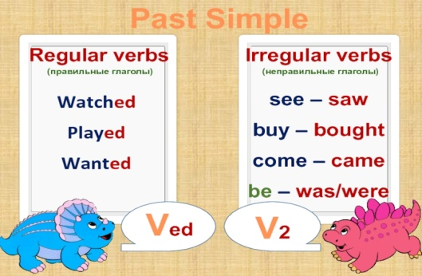  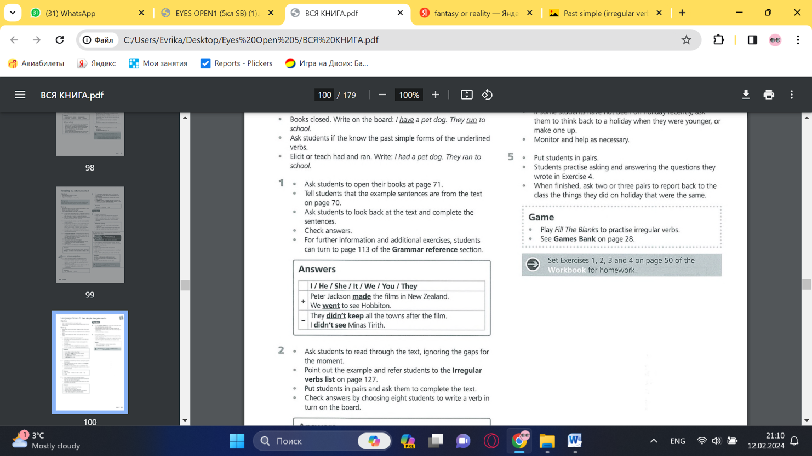  Ex: 1 P: 71  Ask students to open their books at page 71.  Tell students that the example sentences are from the text on page 70.  Ask students to look back at the text and complete the sentences.  Check answers. | Students of the class are listed.  Students' attention is drawn to the lesson.  Determines the topic and purpose of the lesson  Students say different words from the picture and count one to hundred  Pupils complete the examples from the text.  ANSWERS | The teacher to assess learners for their ability.  “Good job!  Well done!”  Formative Assessment  Good job!  Descriptor:  - complete the examples  Total: 2 point | Pictures
 | Ex: 2 P: 71  Ask students to read through the text, ignoring the gaps for the moment.  Point out the exar example and refer students to the Irregular verbs list on page 127.  Put students in pairs and ask them to complete the text.  Check answers by choosing eight students to write a verb in turn on the board.  Ex: 3 P: 71  Ask a student to read out the example sentence.  Students can work alone to rewrite the sentences. Remind them they are making them negative.  Ask students to compare answers in pairs before you check the answers with the class.  Ex: 4 P: 71  To help weaker students, you could elicit some ideas from the class before they make any notes.  If some students have not been on holiday recently, ask them to think back to a holiday when they were younger, or make one up.  Monitor and help as necessary. | Pupils complete the text with the past simple. Use the verbs in brackets.  ANSWERS  2 had  3 saw  4 knew  5 did  6 took  7 got  8 made  Pupils change the sentences into negatives.  ANSWERS  2 He didn't go on holiday with his friends.  3 We didn't get home very late.  4 She didn't know a lot about the castle.  5 I didn't see a lot of interesting things at the museum.  6 It didn't take a long time to get to the beach.  Pupils answer the questions for you. Make notes.  ANSWERS  Students own answer | Descriptor:  - complete the text  - use the verbs in brackets  Total: 2 point  Descriptor:  - change the sentences  - correct the false sentences.  Total: 2 point  Descriptor:  - answer the questions  - make notes.  Total: 2 point  -Make CCQ questions Yes / No  Total: 10 point | Card  Worksheet  Students book
End of the lesson  5 min | FEEDBACK  Learners provide feedback on what they have learned at the lesson.  Ex:  Home task: | Ss evaluate each other and encourage classmate with phrases like:  Well done! Brilliant! Good job! I like it! |  | Poster Success

Short term plan: term 3

Unit 7 Fantasy world |  | Lesson 67
Teacher name:

Date:
Grade: 5 |  | Number present: | absent:
Lesson title | Vocabulary: home and garden
Learning objectives | 5. 2. 4. 1 to understand general and educational topics in a long conversation with the support of the main ideas;  5. 3. 5. 1 attempt to communicate in the exchange of information at the basic level within the framework of various general and educational topics;
Lesson objectives | Learners will be able to:  - learn vocabulary for the home and garden.  -listen to a conversation about a new house.
Value links | "Creativity and Innovation"  Monitoring, measuring, conducting experiments and experiments  ability;
Plan

Stages / Time | Teachers actions | Students actions | Assessment criteria | Resources
Beginning of the lesson  5 min  Middle of the  lesson  Presentation part.  35 min | Organization moment :  1.Greeting.  Ask about the weather.  The teacher sets the lesson objectives, letting students know what to anticipate from the lesson.  Warming up  Revise the language of the previous lesson.  Lead – In    Ex: 1 P: 72  Students work in pairs to do the matching exercise.  Students check their answers and repeat the words.  To extend the work on this, you could ask students turn to the Vocabulary bank on page 121 and do the Home and garden activity. | Students of the class are listed.  Students' attention is drawn to the lesson.  Determines the topic and purpose of the lesson  Students say different words from the picture and count one to hundred  Pupils match the words in the box with the items in the picture. Then listen, check and repeat.  ANSWERS  1 ladder  2 house  3 roof  4 garage  5 barbecue  6 garden  7 wall  8 gate | The teacher to assess learners for their ability.  “Good job!  Well done!”  Formative Assessment  Good job!  Descriptor:  - match the words in the box  - listen, check and repeat  Total: 2 point | Pictures
 | Ex: 2 P: 72  Do this activity with the whole class.  Make sure students understand that they should talk about their own home in this exercise.  Ask for volunteers to give their sentences (students who live in houses will probably find it easier to contribute  Ex: 3 P: 72  Revise the following prepositions of place: opposite, behind, next to, in front of. Do this by putting objects around the class and eliciting the preposition to describe their location.  Students can work in pairs to complete the exercise.  Check answers. | Pupils talk about their own home in this exercise.  ANSWERS  Students own answer.  Pupils write sentences about the garden. Use the prepositions in the box.  ANSWERS  There's a barbecue in front of the house/behind the wall.  There's a tree next to the house.  There's a ladder next to the house / garage.  There's a gate in front of the car.  There's a car behind the gate.  There's a car in front of the house.  There's a car opposite the house | Descriptor:  - talk about your own home  Total: 2 point  Descriptor:  - write sentences about the garden  - use the prepositions  Total: 2 point  -Make CCQ questions Yes / No  Total: 10 point | Card  Worksheet  Students book
End of the lesson  5 min | FEEDBACK  Learners provide feedback on what they have learned at the lesson.  Ex:  Home task: | Ss evaluate each other and encourage classmate with phrases like:  Well done! Brilliant! Good job! I like it! |  | Poster Success

Short term plan: term 3

Unit 7 Fantasy world |  | Lesson 68
Teacher name:

Date:
Grade: 5 |  | Number present: | absent:
Lesson title | Listening: A conversation
Learning objectives | 5. 2. 4. 1 to understand general and educational topics in a long conversation with the support of the main ideas;  5. 3. 7. 1 use subject-specific vocabulary and syntax within a number of general topics;
Lesson objectives | Learners will be able to:  -learn prepositions of location.  -draw and talk about a fantasy garden
Value links | "Creativity and Innovation"  Ability to find optimal ways to solve educational tasks to use new and already familiar algorithms combining, using them in solving non-standard problems
Plan

Stages / Time | Teachers actions | Students actions | Assessment criteria | Resources
Beginning of the lesson  5 min  Middle of the  lesson  Presentation part.  35 min | Organization moment :  1.Greeting.  Ask about the weather.  The teacher sets the lesson objectives, letting students know what to anticipate from the lesson.  Warming up  Revise the language of the previous lesson.  Lead – In    Ex: 4 P: 72  Test students' understanding of the vocabulary in the box by asking them questions, e.g. Have you got a summer house?  Play the recording.  Students work alone to do the exercise.  Students compare answers in pairs before you check answers with the class | Students of the class are listed.  Students' attention is drawn to the lesson.  Determines the topic and purpose of the lesson  Students say different words from the picture and count one to hundred  Pupils listen to Jamie showing his friend Anya around his new house. Write the things in the order he talks about them.  ANSWERS  2 garage  3 table tennis  4 barbecue  5 trees  6 summer house  7 flowers  8 swimming pool | The teacher to assess learners for their ability.  “Good job!  Well done!”  Formative Assessment  Good job!  Descriptor:  - listen to Jamie  - write the things in the order  Total: 2 point | Pictures
 | Ex: 5 P: 72  Read out the five sentences.  Put students into small groups to do the exercise. Remind students they must correct the false sentences.  Ex: 6 P: 72  Give students five minutes to draw their fantasy garden.  Students should label their garden | Pupils listen again. Mark the statements.  ANSWERS  2 F (He wants to play table tennis in the garage.)  3 T  4 F (The vegetable garden is behind the trees / opposite the summer house.)  5 F (Jamie's parents don't want him to play football on the grass.)  Pupils imagine a fantasy garden. Draw a picture to show where things are in your fantasy garden  ANSWERS  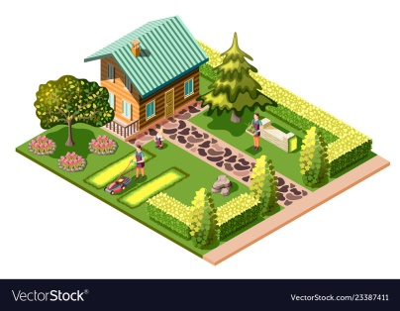 | Descriptor:  - listen again  - mark the statements.  Total: 2 point  Descriptor:  - imagine a fantasy garden  - draw a picture your fantasy garden  Total: 2 point  -Make CCQ questions Yes / No  Total: 10 point | Card  Worksheet  Students book
End of the lesson  5 min | FEEDBACK  Learners provide feedback on what they have learned at the lesson.  Ex:  Home task: | Ss evaluate each other and encourage classmate with phrases like:  Well done! Brilliant! Good job! I like it! |  | Poster Success

Short term plan: term 3

Unit 7 Fantasy world |  | Lesson 69
Teacher name:

Date:
Grade: 5 |  | Number present: | absent:
Lesson title | Language focus: Prepositions of location
Learning objectives | 5. 2. 6. 1 to determine a number of general and educational topics with the support of meaning from the context of a short conversation;  5. 5. 2. 1 systematic writing of sentences in a paragraph on some general and educational topics with the support of the teacher;  5. 6. 3. 1 use of adjectives, including dependent adjectives, when describing things in general and educational topics, use of simple one-syllable and two-syllable adjectives (comparative and
Lesson objectives | Learners will be able to:  - learn more prepositions of location.  - talk about where things are.
Value links | "Creativity and Innovation"  Use of various cognitive tools, knowledge about the world be able to collect (linguistic, reading culture, information, service in the digital environment)
Plan

Stages / Time | Teachers actions | Students actions | Assessment criteria | Resources
Beginning of the lesson  5 min  Middle of the  lesson  Presentation part.  35 min | Organization moment :  1.Greeting.  Ask about the weather.  The teacher sets the lesson objectives, letting students know what to anticipate from the lesson.  Warming up  Revise the language of the previous lesson.  Lead – In  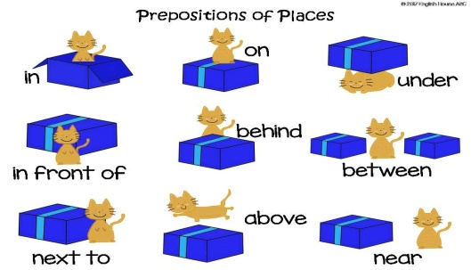  Ex: 1 P: 73  Using objects in the classroom, e.g. a book or a pen, elicit the prepositions in the box. Put the object in various places around the room and then ask: Where is it? Students say: It's on the floor. It's in the bag. It's against the window, etc.  Students work in pairs to do the exercise.  Check answers. | Students of the class are listed.  Students' attention is drawn to the lesson.  Determines the topic and purpose of the lesson  Students say different words from the picture and count one to hundred  Pupils complete the examples from the listening.  ANSWERS  2 in  3 outside  4 at  5 on the left  6 on | The teacher to assess learners for their ability.  “Good job!  Well done!”  Formative Assessment  Good job!  Descriptor:  - work in pairs  - complete the examples  Total: 2 point | Pictures
 | Ex: 2 P: 73  Allow students a minute to read through the text about a castle.  To help weaker students, read the first example with the class.  Put students in pairs to complete the exercise.  Ask students to compare their answers with another pair before checking with the class.  Ex: 3 P: 73  Allow students a minute to read through the sentences.  Read out the first sentence and the circled answer. Ask students why the first option is incorrect. (of is never used after opposite)  Students work alone to complete the exercise.  Put students in pairs to compare their answers.  Ex: 4 P: 73  Draw students' attention to the picture and ask them to tell you the names of some of the objects in the room, e.g. guitar, desk, laptop, bed, wall, etc.  Ask students to look at the prompts and make sure they know all the vocabulary.  Read out the first prompt and the example answer. Explain to students they have to use the other prompts in the same way to make sentences and will need to refer to the picture to help them. | Pupils complete the description of a castle with prepositions from the box.  ANSWERS  2 outside /next to  3 Inside/In  4 In  5 on  6 Against  7 next to  8 behind  Pupils choose the correct prepositions to complete the sentences.  ANSWERS  2 on; in  3 on  4 at  5 in  Pupils make sentences about Mark’s bedroom. Use the prompts and picture.  ANSWERS  2 The laptop is on the desk.  3 The bookshelves are against / next to the wall.  4 The chair is next to / in front of the desk.  5 The brown guitar is against / next to the wall.  6 The pictures are on the wall. | Descriptor:  - read through the text about a castle  - complete the description of a castle with prepositions  Total: 2 point  Descriptor:  - choose the correct prepositions  - complete the sentences  Total: 2 point  Descriptor:  - make sentences  - use the prompts and picture  Total: 2 point  -Make CCQ questions Yes / No  Total: 10 point | Card  Worksheet  Students book
End of the lesson  5 min | FEEDBACK  Learners provide feedback on what they have learned at the lesson.  Ex:  Home task: | Ss evaluate each other and encourage classmate with phrases like:  Well done! Brilliant! Good job! I like it! |  | Poster Success

Short term plan: term 3

Unit 7 Fantasy world |  | Lesson 70
Teacher name:

Date:
Grade: 5 |  | Number present: | absent:
Lesson title | Discovery culture
Learning objectives | 5. 5. 3. 1 write specific details with the support of the teacher, describing people, places and objects at the text level;  5. 6. 14. 1 on some familiar general and academic topics, use auxiliaries to talk about time and location, to indicate the subject, auxiliaries to describe things, to, into, out of, from, towards auxiliaries to indicate the direction of movement using words;
Lesson objectives | Learners will be able to:  - watch a video about transport in big cities.  - talk about my favourite form of transport.
Value links | "Independence and patriotism",  To the past, present and future of the people understand the relevance
Plan

Stages / Time | Teachers actions | Students actions | Assessment criteria | Resources
Beginning of the lesson  5 min  Middle of the  lesson  Presentation part.  35 min | Organization moment :  1.Greeting.  Ask about the weather.  The teacher sets the lesson objectives, letting students know what to anticipate from the lesson.  Warming up  Revise the language of the previous lesson.  Lead – In    Ex: 1 P: 74  Ask students to open their books at page 74.  Read out the phrases in the box.  Put students in pairs to do the exercise.  Check answers.  Ask: Which of the forms of transport in the pictures is your favourite | Students of the class are listed.  Students' attention is drawn to the lesson.  Determines the topic and purpose of the lesson  Students say different words from the picture and count one to hundred  Pupils match pictures with the words.  ANSWERS  1 aeroplane  2 underground  3 zebra crossing  4 bullet train  5 tuk-tuk/rickshaw  6 traffic jam | The teacher to assess learners for their ability.  “Good job!  Well done!”  Formative Assessment  Good job!  Descriptor:  - match pictures  - complete the examples  Total: 2 point | Pictures
 | Ex: 2 P: 74  Do this activity with the whole class.  Write the names of the cities on the board. Students say which pictures go with which city.  Do not confirm answers at this point  Ex: 3 P: 74  Play the video.  Students check their answers to Exercise 2  Ex: 4 P: 74  Check understanding of ride (noun), aerial view and passenger.  Play the video.  Students work alone to do the exercise.  Students compare answers in pairs before you play the video again and check answers with the class.  Ex: 5 P: 74  Students work in pairs to complete the sentences with the correct numbers.  Tell students this exercise tests memory. They shouldn't worry if they don't remember the numbers.  Play the video again.  Find out which pair had the most correct numbers.  Ex: 6 P: 74  Ask students to work alone to complete the matching exercise.  Students compare answers in pairs before you compare answers with the class.  To extend this activity, you could ask students to work in pairs to write a sentence describing transport in their town or city. | Pupils match the transport words in ex 1 with the cities.  ANSWERS  Students own answer.  Pupils watch the video about transport in the three cities and check your answers.  ANSWERS  Mumbai (India): tuk-tuk / rickshaw  Tokyo (Japan): zebra crossing, underground, bullet train, aeroplane  Beijing (China): traffic jam  Pupils watch the video again put these fast-moving images in order.  ANSWERS  b-d-f-a-c-e  Pupils complete the sentences with the correct numbers. Then watch again and check your answers.  ANSWERS  1 20  2 300  3 600  4 36  5 9  Pupils match the sentences to the three different cities.  ANSWERS  1 Mumbai  2 Tokyo  3 Beijing | Descriptor:  - match the transport words  - check your answers.  Total: 2 point  Descriptor:  - watch the video about transport  - check your answers.  Total: 2 point  Descriptor:  - watch the video again  - put the fast-moving images in order  Total: 2 point  Descriptor:  - complete the sentences with the correct numbers  - check your answers.  Total: 2 point  Descriptor:  - match the sentences  - write a sentence describing transport in their town or city.  Total: 2 point  -Make CCQ questions Yes / No  Total: 10 point | Card  Worksheet  Students book
End of the lesson  5 min | FEEDBACK  Learners provide feedback on what they have learned at the lesson.  Ex:  Home task: | Ss evaluate each other and encourage classmate with phrases like:  Well done! Brilliant! Good job! I like it! |  | Poster Success
Short term plan: term 3

Unit 7 Fantasy world |  | Lesson 71
Teacher name:

Date:
Grade: 5 |  | Number present: | absent:
Lesson title | Reading: Hong Kong
Learning objectives | 5. 5. 6. 1 logically combine sentences into paragraphs with some support using basic connectives on some common topics;  5. 6. 3. 1 use of adjectives, including dependent adjectives, when describing things in general and educational topics, use of simple one-syllable and two-syllable adjectives (comparative and selective) for comparison;
Lesson objectives | Learners will be able to:  - read a text about public transport in Hong Kong.  - learn transport collocations.  - ask and answer questions about my journey to school
Value links | "Independence and patriotism",  Assessment of the importance of loyalty to the motherland, the history of the country respect culture
Plan

Stages / Time | Teachers actions | Students actions | Assessment criteria | Resources
Beginning of the lesson  5 min  Middle of the  lesson  Presentation part.  35 min | Organization moment :  1.Greeting.  Ask about the weather.  The teacher sets the lesson objectives, letting students know what to anticipate from the lesson.  Warming up  Revise the language of the previous lesson.  Lead – In    Ex: 1 P: 75  Refer students to the map and photos.  Ask students to identify the different types of transport shown in the photos.  Read the questions and then ask students to read the text quickly to find the answers | Students of the class are listed.  Students' attention is drawn to the lesson.  Determines the topic and purpose of the lesson  Students say different words from the picture and count one to hundred  Pupils look at the map and the pictures. Answer the question. Read David’s blog and check your answers.  ANSWERS  People travel by ferry, bus, tram and underground.. It is easy to travel in Hong Kong. | The teacher to assess learners for their ability.  “Good job!  Well done!”  Formative Assessment  Good job!  Descriptor:  - look at the map  - answer the question  Total: 2 point | Pictures
 | Ex: 2 P: 75  Check students' understanding of the word route (the path you follow to go from one place to another) and then refer them to the map.  Ask students to work in pairs to draw David's route to school.  Ex: 3 P: 75  Give students a minute to read the sentences.  Ask students to work alone to read the text and then complete the exercise.  Students can compare answers in pairs before you check answers with the class.  Check answers.  Ex: 4 P: 75  Refer students to the words in bold in the text and check their understanding of them.  Put students in pairs to complete the text with the collocations from the text.  To extend the work on this vocabulary, you could ask students to turn to the Vocabulary Bank on page 121 and do the Collocations activity in Explore vocabulary. | Pupils look at the map of Hong Kong. Read the text again and draw David’s route to school in the morning.  ANSWERS  walk from home to the underground station in Mong Kok ferry across Victoria Harbour - tram - escalator to his school in Mid-Levels  Pupils read the text again. Choose the correct answers.  ANSWERS  1 on foot  2 the tram  3 didn't take  4 fun  Pupils look at the highlighted words in the text. Complete the paragraph below with the correct word.  ANSWERS  1 on  2 by  3 take  4 by | Descriptor:  - look at the map  - read the text  Total: 2 point  Descriptor:  - read the text  - choose the correct answers  Total: 2 point  Descriptor:  - look at the highlighted words  - complete the paragraph  Total: 2 point  -Make CCQ questions Yes / No  Total: 10 point | Card  Worksheet  Students book
End of the lesson  5 min | FEEDBACK  Learners provide feedback on what they have learned at the lesson.  Ex:  Home task: | Ss evaluate each other and encourage classmate with phrases like:  Well done! Brilliant! Good job! I like it! |  | Poster Success

Short term plan: term 3

Unit 7 Fantasy world |  | Lesson 72
Teacher name:

Date:
Grade: 5 |  | Number present: | absent:
Lesson title | Speaking: Sequencing
Learning objectives | 5. 2. 7. 1 of a simple conversational speaker with teacher assistance on a range of general and academic topics  5. 4. 2. 1 understand specific information in simple, short texts on a number of general and educational topics with little help from the teacher;
Lesson objectives | Learners will be able to:  -watch teenagers talking about where they usually go with their friends.  - listen to someone talk about what they did at the weekend.  - talk about where I usually go with my friends.  - practise using sequencing words
Value links | "Independence and patriotism"  Respect the state symbols of Kazakhstan, understand the meaning of public holidays
Plan

Stages / Time | Teachers actions | Students actions | Assessment criteria | Resources
Beginning of the lesson  5 min  Middle of the  lesson  Presentation part.  35 min | Organization moment :  1.Greeting.  Ask about the weather.  The teacher sets the lesson objectives, letting students know what to anticipate from the lesson.  Warming up  Revise the language of the previous lesson.  Lead – In    Ex: 1 P: 76  Ask students to open their books at page 76.  Tell students they are going to watch some teenagers answering the following question:  Where do you usually go with your friends?  Give students time to read the questions and then play the video.  Students work alone to answer the questions.  Students compare answers in pairs before you check answers with the class | Students of the class are listed.  Students' attention is drawn to the lesson.  Determines the topic and purpose of the lesson  Students say different words from the picture and count one to hundred  Pupils watch the teenagers in the video. Answer the question.  ANSWERS  go to the shopping centre - 3  go to their friends' houses - 2  eat or drink something - 3  go to the park-2 | The teacher to assess learners for their ability.  “Good job!  Well done!”  Formative Assessment  Good job!  Descriptor:  - watch the teenagers in the video  - answer the question.  Total: 2 point | Pictures
 | Ex: 2 P: 76  Students work in pairs to ask and answer the question.  Students could answer additional questions, e.g. Have you got a favourite place that you go to with your friends?  Ask some students to report back to the class on what their partner said  Ex: 3 P: 76  Give students time to read the question, then play the recording.  Students compare answers in pairs before you check the answers with the class.  Ex: 4 P: 76  Read out the list of words and phrases in the Useful language box. Check students' understanding and elicit example sentences using these words and phrases. Ask students to work in pairs to complete the conversation  Ex: 5 P: 76  Play the recording for students to listen and check their answers to Exercise 4. | Pupils ask and answer with a partner.  ANSWERS  Students own answer.  Pupils listen to the conversation. Answer the question.  ANSWERS  Charlie - homework David - went on a helicopter  Pupils complete the conversation with the useful language.  ANSWERS  Students own answer.  Pupils listen again and check your answers.  ANSWERS  1 Really  2 So you  3 First  4 Then  5 After that | Descriptor:  - work in pairs  - ask and answer  Total: 2 point  Descriptor:  - listen to the conversation  - answer the question.  Total: 2 point  Descriptor:  - read out the list of words and phrases  - complete the conversation  Total: 2 point  -Make CCQ questions Yes / No  Total: 10 point | Card  Worksheet  Students book
End of the lesson  5 min | FEEDBACK  Learners provide feedback on what they have learned at the lesson.  Ex:  Home task: | Ss evaluate each other and encourage classmate with phrases like:  Well done! Brilliant! Good job! I like it! |  | Poster Success

Short term plan: term 3

Unit 7 Fantasy world |  | Lesson 73
Teacher name:

Date:
Grade: 5 |  | Number present: | absent:
Lesson title | Writing: A description of a place
Learning objectives | 5. 2. 7. 1 of a simple conversational speaker with teacher assistance on a range of general and academic topics  5. 4. 6. 1 identify the author's opinion or point of view in short texts on some general and educational topics
Lesson objectives | Learners will be able to:  - read a description of a place.  - learn about adding information to a sentence using also and too.  - write a description of a place
Value links | "Independence and patriotism",  To the past, present and future of the people understand the relevance
Plan

Stages / Time | Teachers actions | Students actions | Assessment criteria | Resources
Beginning of the lesson  5 min  Middle of the  lesson  Presentation part.  35 min | Organization moment :  1.Greeting.  Ask about the weather.  The teacher sets the lesson objectives, letting students know what to anticipate from the lesson.  Warming up  Revise the language of the previous lesson.  Lead – In  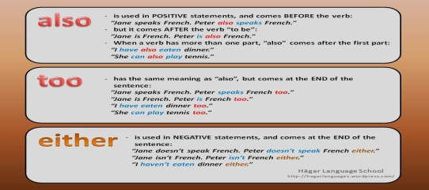  Ex: 1 P: 77  Ask students to open their books at page 77 and describe the photos.  Students say where they think the town is and then check their answer with the text.  Tell students the town pictured is called Tavistock and that it is in England. The pictures show Tavistock's town hall and a statue of Sir Francis Drake. | Students of the class are listed.  Students' attention is drawn to the lesson.  Determines the topic and purpose of the lesson  Students say different words from the picture and count one to hundred  Pupils look at the photos. Answer the question.  ANSWERS  It's in England | The teacher to assess learners for their ability.  “Good job!  Well done!”  Formative Assessment  Good job!  Descriptor:  - look at the photos.  - answer the question.  Total: 2 point | Pictures
 | Ex: 2 P: 77  Give students a couple of minutes to read the email and answer the question. Students can compare their answers in pairs before you check answers with the class.  Ex: 3 P: 77  Read out the headings.  Ask students to work alone to put the headings in the right place.  Students can compare answers in pairs before you check answers with the class.  Ex: 4 P: 77  Read out the information in the Useful language box. Make sure that students understand that also and too are used in different places in a sentence.  Students can work in pairs to find examples in the text in Exercise 1.  Ex: 5 P: 77  Ask a student to read out the example.  Ask students to work in pairs to complete the rest of the exercise.  Encourage weaker students to check their first sentence with you before they complete the exercise. | Pupils read Kristie’s email to Nicole. Check your answers. Answer the question.  ANSWERS  You can go to a museum or a concert. You can visit Dartmoor National Park. There are shops, parks and sports facilities  Pupils put the paragraph headings in the correct place Kristie’s email.  ANSWERS  1 Size and location  2 History and interesting facts  3 Things to do and places to visit  Pupils find more examples of also and too in the text .  ANSWERS  He was also the second person to sail all the way around the world.  There are a lot of historical buildings in Tavistock, and a museum, too.  We can also visit the Dartmoor National Park!  There are lots of shops, parks, and sports facilities, too  Pupils rewrite the sentences using also or too.  ANSWERS  2 We can go to the mountains, too.  3 We have a carnival in August, too.  4 Lots of people also visit the beautiful beaches.  5 They also make traditional products. | Descriptor:  - read Kristie’s email to Nicole  - answer the question.  Total: 2 point  Descriptor:  - put the paragraph headings in the correct place  Total: 2 point  Descriptor:  - find more examples  - complete the tsk  Total: 2 point  Descriptor:  - rewrite the sentences  - use also or too.  Total: 2 point  -Make CCQ questions Yes / No  Total: 10 point | Card  Worksheet  Students book
End of the lesson  5 min | FEEDBACK  Learners provide feedback on what they have learned at the lesson.  Ex:  Home task: | Ss evaluate each other and encourage classmate with phrases like:  Well done! Brilliant! Good job! I like it! |  | Poster Success
Short term plan: term 3

Unit 7 Fantasy world |  | Lesson 74
Teacher name:

Date:
Grade: 5 |  | Number present: | absent:
Lesson title | CLIL: Design and Technology
Learning objectives | 5. 2. 7. 1 of a simple conversational speaker with teacher assistance on a range of general and academic topics  5. 4. 6. 1 identify the author's opinion or point of view in short texts on some general and educational topics  5. 5. 2. 1 systematic writing of sentences in a paragraph on some general and educational topics with the support of the teacher;
Lesson objectives | Learners will be able to:  - learn the names for and use of different drawing tools.  - distinguish between tools used in Art and tools used in Maths.  - copy shapes into your notebook
Value links | "Independence and patriotism",  Assessment of the importance of loyalty to the motherland, the history of the country respect culture
Plan

Stages / Time | Teachers actions | Students actions | Assessment criteria | Resources
Beginning of the lesson  5 min  Middle of the  lesson  Presentation part.  35 min | Organization moment :  1.Greeting.  Ask about the weather.  The teacher sets the lesson objectives, letting students know what to anticipate from the lesson.  Warming up  Revise the language of the previous lesson.  Lead – In  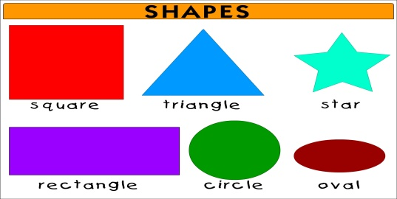  Ex: 1 P: 78  Ask students to open their books at page 78 and read out the words in the box.  Students can work in pairs to match the drawing tools in the picture with the words. | Students of the class are listed.  Students' attention is drawn to the lesson.  Determines the topic and purpose of the lesson  Students say different words from the picture and count one to hundred  Pupils look at the picture. Match the drawing tools with the words in the box. Then listen and check.  ANSWERS  2 paper  3 drawing board  4 ruler y  5 compass  6 t-square  7 pencils  8 coloured pencils  9 felt-tip pens | The teacher to assess learners for their ability.  “Good job!  Well done!”  Formative Assessment  Good job!  Descriptor:  - look at the picture.  - match the drawing tools with the words  Total: 2 point | Pictures
 | Put the following language on the board and ask students to use it in this task: I think this is a What about you? / I'm not sure what it is.  I (dis)agree. I think it's a  Play the recording for students to check their answers.  Ask students to tell a partner what drawing tools they have in their pencil cases or bags.  Ex: 2 P: 78  Draw a right-angled triangle on the board:  Write the degree symbol (°) on the board. Explain or elicit that we measure angles in degrees. Point to the 90-degree angle on the triangle on the board.  Draw parallel, straight and curved lines to teach these words. Ask students to work in pairs to complete the table.  Ex: 3 P: 78  Play the recording for students to check their answers to Exercise 2.  Ex: 4 P: 78  Write In Maths, In Art and Both on the board.  Ask individual students to come up to the board and write their answers under one of the three headings.  Ex: 5 P: 78  Ask: What shapes can you see in the picture? Write the words on the board. Students will probably know triangle and circle, but you may have to teach them: rectangular, cuboid.  Students say what drawing tools they need to draw the three shapes and then draw the shapes in their notebooks. If they need help with how to do this, they can take a look here: | Pupils complete the table about the drawing tools with the words in the box.  ANSWERS  Students own answers.  Pupils listen to the conversation and check your answers.  ANSWERS  2 parallel  3 angles  4 circles  5 straight  6 colour  Pupils answer the question.  ANSWERS  In Maths: compass, ruler, setsquare, t-square  In Art: coloured pencils  In both: drawing board, felt-tip pens, paper, pencils  Pupils look at the shapes. Copy them. Answer the question.  ANSWERS  Circle: compass, coloured pencils Triangle: ruler, compass, setsquare Cuboid: ruler | Descriptor:  - work in pairs  - complete the table  Total: 2 point  Descriptor:  - listen to the conversation  - check your answers.  Total: 2 point  Descriptor:  - look at the shapes  - answer the question.  Total: 2 point  -Make CCQ questions Yes / No  Total: 10 point | Card  Worksheet  Students book
End of the lesson  5 min | FEEDBACK  Learners provide feedback on what they have learned at the lesson.  Ex:  Home task: | Ss evaluate each other and encourage classmate with phrases like:  Well done! Brilliant! Good job! I like it! |  | Poster Success

Short term plan: term 3

Unit 7 Fantasy world |  | Lesson 75
Teacher name:

Date:
Grade: 5 |  | Number present: | absent:
Lesson title | Extra reading: I live in Nursultan  Summative assessment for the unit ”Fantasy world”
Learning objectives | 5. 2. 6. 1 to determine a number of general and educational topics with the support of meaning from the context of a short conversation;  5. 3. 7. 1 using subject-specific vocabulary and syntax within a range of general topics  5. 4. 6. 1 identify the author's opinion or point of view in short texts on some general and educational topics
Lesson objectives | Learners will be able to:  - read a text about Astana.  - answer comprehension questions about the text.  - talk about capital cities around the world
Value links | "Independence and patriotism"  Respect the state symbols of Kazakhstan, understand the meaning of public holidays
Plan

Stages / Time | Teachers actions | Students actions | Assessment criteria | Resources
Beginning of the lesson  5 min  Middle of the  lesson  Presentation part.  35 min | Organization moment :  1.Greeting.  Ask about the weather.  The teacher sets the lesson objectives, letting students know what to anticipate from the lesson.  Warming up  Lead – In    Ex: 1 P: 79  Before students read the text, explain or elicit the meaning of the following vocabulary: apartment (point out that apartment is used in the US, flat in the UK), entertainment, feed, tent, museum.  Ask students to work alone to read the text and answer the questions. | Students of the class are listed.  Students' attention is drawn to the lesson.  Determines the topic and purpose of the lesson  Students say different words from the picture and count one to hundred | The teacher to assess learners for their ability.  “Good job!  Well done!”  Formative Assessment  Good job! | Pictures
 | Students can compare answers in pairs before you check them with the class.  Help weaker students by showing them how to scan a text to find key words. Scanning refers to reading a text quickly to find specific information. For example, to find the answer to Question 1, students need to scan the text to find 'Duman Entertainment Centre'.  After you have checked the answers to the exercise, you can extend the task by asking additional questions to test comprehension. For example: Where in Astana does Alina live? (In the city centre.) Does she live in a house? (No, she doesn't. She lives in an apartment.) How old is she? (She is 11.) What grade is she in at school? (In the fifth grade.) Where does she go with her friends? (The Duman Entertainment Centre, the swimming pool at the Khan Shatyr Entertainment Centre.  Summative assessment for the unit ”Fantasy world” | Pupils read the text, then answer the question.  ANSWERS  1 Visit the aquarium and see the shark show, go to the 4D theatre.  2 A tent.  3 Swimming, golf.  4. Traditional Kazakh knives, carpets, coins and furniture | Descriptor:  - read the text  - answer the question  Total: 2 point  -Make CCQ questions Yes / No  Total: 10 point | Card  Worksheet  Students book
End of the lesson  5 min | FEEDBACK  Learners provide feedback on what they have learned at the lesson.  Ex:  Home task: | Ss evaluate each other and encourage classmate with phrases like:  Well done! Brilliant! Good job! I like it! |  | Poster Success

Short term plan: term 3

Unit 7 Fantasy world |  | Lesson 76
Teacher name:

Date:
Grade: 5 |  | Number present: | absent:
Lesson title | 5-7 Review
Learning objectives | 5. 4. 1. 1 understand the main idea of ​​some simple short texts on general and educational topics;  5. 2. 8. 1 supported understanding of general and academic topics in a range of longer conversations, including stories  5. 3. 1. 1 provide basic information about oneself and others at the sentence level within a number of general topics;
Lesson objectives | Learners will be able to:  - use vocabulary for different Arts activities.  - use vocabulary for places in a town.
Value links | "Independence and patriotism",  To the past, present and future of the people understand the relevance
Plan

Stages / Time | Teachers actions | Students actions | Assessment criteria | Resources
Beginning of the lesson  5 min  Middle of the  lesson  Presentation part.  35 min | Organization moment :  1.Greeting.  Ask about the weather.  Warming up  The teacher sets the lesson objectives, letting students know what to anticipate from the lesson.  Lead – In  Ex: 1 P: 80  Explain the task and allow Ss some time to complete it. Match the activities with pictures.  Check Ss' answers. | Students of the class are listed.  Students' attention is drawn to the lesson.  Determines the topic and purpose of the lesson  Students say different words from the picture and count one to hundred  Pupils match the activities with pictures  ANSWERS  2 read books  3 dance  4 draw  5 paint  6 sing  7 take photos  8 act  9 write stories | The teacher to assess learners for their ability.  “Good job!  Well done!”  Formative Assessment  Good job!  Descriptor:  - match the activities with pictures  Total: 2 point | Pictures
 | Ex: 2 P: 80  Explain the task and allow Ss some time to complete it. Complete the music word. Check Ss' answers.  Ex: 3 P: 80  Explain the task and allow Ss some time to complete it. Match the activities with the places. Check Ss' answers.  Ex: 4 P: 80  Explain the task and allow Ss some time to complete it. Match the activities with pictures. Check Ss' answers.  Ex: 5 P: 80  Explain the task and allow Ss some time to complete it. Match the adjectives with the definition. Check Ss' answers. | Pupils complete the music word  ANSWERS  2 soul  3 rap  4 hip-hop  5 classical  6 folk  7 rock  8 jazz  9 opera  Pupils match the activities with the places  ANSWERS  2 e  3 f  4 b  5 a  6 c  7 h  8 g  Pupils match the activities with pictures  ANSWERS  2 garden  3 ladder  4 barbecue  5 wall  6 garage  7 roof  8 gate  Pupils match the adjectives with the definition  ANSWERS  1 d  2 b  3 a  4 c | Descriptor:  - complete the music word  Total: 2 point  Descriptor:  - match the activities with the places  Total: 2 point  Descriptor:  - match the activities with pictures  Total: 2 point  Descriptor:  - match the adjectives with the definition  Total: 2 point  -Make CCQ questions Yes / No  Total: 10 point | Card  Worksheet  Students book
End of the lesson  5 min | FEEDBACK  Learners provide feedback on what they have learned at the lesson.  Ex:  Home task: | Ss evaluate each other and encourage classmate with phrases like:  Well done! Brilliant! Good job! I like it! |  | Poster Success

Short term plan: term 3

Unit7: Unit 3 Fantasy world |  | Lesson 77

Teacher name:

Date:
Grade: 5 |  | Number present: | absent:
Lesson title | Summative control work for the 3rd term
Learning objectives | 5.2.4.1 Understand the main points of supported extended talk on a range of general and curricular topics.  5.4.2.1 Understand with little support specific information and detail in short, simple texts on a limited range of general and curricular topics.  5.5.6.1 Link, with some support, sentences into coherent paragraphs using basic connectors on a limited range of familiar general topics.  5.3.1.1 Provide basic information about themselves and others at sentence level on an increasing range of general topics.
Lesson objectives | Learners will be able to:  - summarize the main idea with the limited support of details they hear or write down  -identify the details of a text  - use simple transitional phrases (firstly, secondly…, in conclusion, then, but)  -convey ideas and basic information (age, hobbies, interests, family and educational background)
Value links | "Independence and patriotism"  Respect the state symbols of Kazakhstan, understand the meaning of public holidays
Plan

Stages / Time | Teachers’ actions | Students’ actions | Assessment criteria | Resources
Beginning of the lesson  5 min | Organization moment  1.Greeting.  Ask about the weather.  The teacher sets the lesson objectives, letting students know what to anticipate from the lesson.  Warm-up  Fasten your seat belts and get ready for the all-round race  Lead – In  Books closed. Write the following words on the board in random order: country, village, city, town. Tell students to work in pairs to put these places in order of size, starting with the largest. Ask them to think of an example of each place from their own country.  After about 1 minute, stop the students. Get feedback from each pair. | Students' attention is drawn to the lesson.  Students discuss the pictures in pairs.  Determines the topic and aim of the lesson  Students say different words from the picture | Formative Assessment  Good job!  Assessment criteria  - Support a talk on a given general topic | Pictures  Student’s book
Middle of the lesson  Presentation part.  35 min | Tasks for the Summative Assessment for the term 3  Listening  Task. Listen to the recording and write the name of each room in the correct place on the Floor plan. You will listen to the recording twice.  CD3. Tapescript 3.  Reading  Task. Read the text and complete the sentences using the words from the box in the correct form  Writing  Task. Think about imaginary place you would like to live. Describe it. The following  questions will help you.  What place is it?  Why would you like to live there?  What is the weather there?  What does this place have?  What can you there?  What can you do there?  Speaking  Task. Choose ONE card, speak about the topic and answer the questions.  Conclusion during the lesson some tasks differentiated by outcomes of the students and by their abilities. | Students listen to the recording and write the name of each room  Descriptor:  - write the names of each room.  Differentiation:  «Verbal support» method is used to help Students use new words in the text.  Students Read the text and complete the sentences using the words from the box  Descriptor:  -read the text  -complete the sentences  Students describe the places and write using the following questions.  Descriptor:  - describe the places  Differentiation by support  Less motivated learners will be given prompts to find the correct location of the text() paragraphs  Students choose one card to speak about the topic  Descriptor:  - speak using questions  Differentiation by support  Less motivated learners will be given prompts to find the correct location of the text() paragraphs | - can write the names of each room.  Total: 5 point  -can read the text  Total: 5 point  -can describe the places  Total: 5 point  -can speak using questions  Total: 5 point | Cards  Worksheets
End of the lesson  5 min | FEEDBACK  Learners provide feedback on what they have learned at the lesson. | Ss evaluate each other and encourage classmate with phrases like:  Well done! Brilliant! Good job! I like it! | Students evaluate each other and encourage classmate with phrases like:  Well done! Brilliant! Good job! I like it! . | Poster
Short term plan: term 3

Unit 7 Fantasy world |  | Lesson 78
Teacher name:

Date:
Grade: 5 |  | Number present: | absent:
Lesson title | Language focus
Learning objectives | 5. 3. 7. 1 using subject-specific vocabulary and syntax within a range of general topics  5. 4. 6. 1 identify the author's opinion or point of view in short texts on some general and educational topics  5. 5. 6. 1 logically combine sentences into paragraphs with some support using basic connectives on some common topics;
Lesson objectives | Learners will be able to:  - use vocabulary for different Arts activities.  - use vocabulary for places in a town.
Value links | "Independence and patriotism"  Respect the state symbols of Kazakhstan, understand the meaning of public holidays
Plan

Stages / Time | Teachers actions | Students actions | Assessment criteria | Resources
Beginning of the lesson  5 min  Middle of the  lesson  Presentation part.  35 min | Organization moment :  1.Greeting.  Ask about the weather.  Warming up  The teacher sets the lesson objectives, letting students know what to anticipate from the lesson.  Lead – In  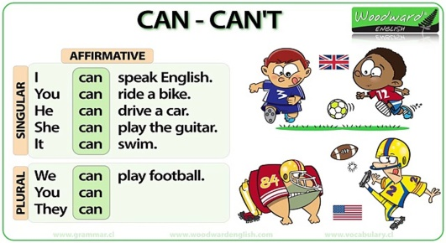  Ex: 1 P: 80  Explain the task and allow Ss some time to complete it. Write sentences with the correct form of can.  Check Ss' answers. | Students of the class are listed.  Students' attention is drawn to the lesson.  Determines the topic and purpose of the lesson  Students say different words from the picture and count one to hundred  Pupils write sentences with the correct form of can.  ANSWERS  2 Maria can dance.  3 Can we go home?  4 Victor can't play the guitar.  5 Can you swim?  6 They can do Kung Fu. | The teacher to assess learners for their ability.  “Good job!  Well done!”  Formative Assessment  Good job!  Descriptor:  - write sentences with the correct form  Total: 2 point | Pictures
 | Ex: 2 P: 80  Explain the task and allow Ss some time to complete it. Complete the text with the correct object pronouns. . Check Ss' answers.  Ex: 3 P: 80  Explain the task and allow Ss some time to complete it. Complete the sentences with the .-ing form of the verbs in the box. Check Ss' answers.  Ex: 4 P: 80  Explain the task and allow Ss some time to complete it. Complete the explanation with the prepositions. Check Ss' answers. | Pupils complete the text with the correct object pronouns.  ANSWERS  2 me  3 him  4 us  5 it  6 them  Pupils complete the sentences with the .-ing form of the verbs in the box  ANSWERS  2 playing  3 eating  4 reading  5 listening  6 riding  Pupils complete the explanation with the prepositions  ANSWERS  2 in  3 next to  4 behind  5 on the right  6 in front of  7 inside/in | Descriptor:  - complete the text with the correct object pronouns  Total: 2 point  Descriptor:  - complete the sentences with the -ing form  Total: 2 point  Descriptor:  - complete the explanation with the prepositions  Total: 2 point  -Make CCQ questions Yes / No  Total: 10 point | Card  Worksheet  Students book
End of the lesson  5 min | FEEDBACK  Learners provide feedback on what they have learned at the lesson.  Ex:  Home task: | Ss evaluate each other and encourage classmate with phrases like:  Well done! Brilliant! Good job! I like it! |  | Poster Success

